QVAUctor ltd

Connect WIP to SAP-BI Server
Installation Guidelines

CONFIGURATION MANAGEMENT
Doc ID: | WIP Connect to SAP-BI Server
Author: | Golay Jean-Philippe | Issue Date: | 13 November 2019

Table of Contents
1 Overview 2
1.1 Prerequisites 2
1.2 Supplementary Prerequisites for SAP-BI 2
2 Installing WIP 2
3 Installing SAP-BI Client tools 3
3.1 Clients Components 3
3.2 Developer Components 4
3.3 Database Access and Security 5
4 Configure SAP-BI Connector 6

Overview

Prerequisites

Please consult WIP Install Guide.pdf for prerequisites

Supplementary Prerequisites for SAP-BI

SAP-BI Client Tool BI4.2 SP5 and further (SP4 OK, SP3 might work but not fully tested)
SAP-BI Client Tool
- Screenshots (With options Selected for Java and Rest API)

Installing WIP
See document WIP Install Guide run the standard WIP Install procedure.
In the modules ensure you have selected SAP Service
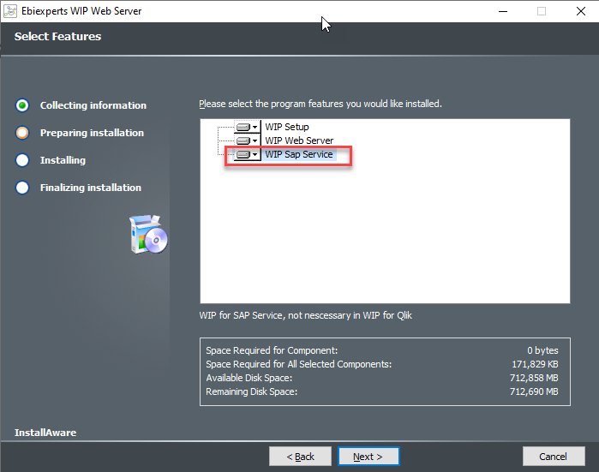

Installing SAP-BI Client tools
Run the SAP-BI Client tools installer on the WIP Web Server. It is important to run the SAP complete installation, not an in-house installation.
If you have multiple SAP BI versions in your company, install the greater version you have on your servers/clients

Clients Components
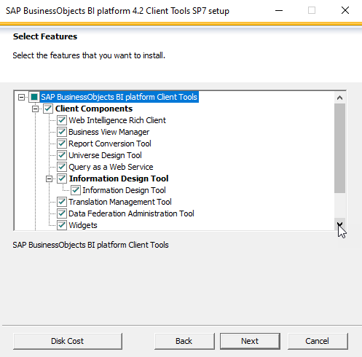
In the “Clients Components” WIP needs at least (else check all)
- Universe Design Tool
- Information Design Tool

Developer Components
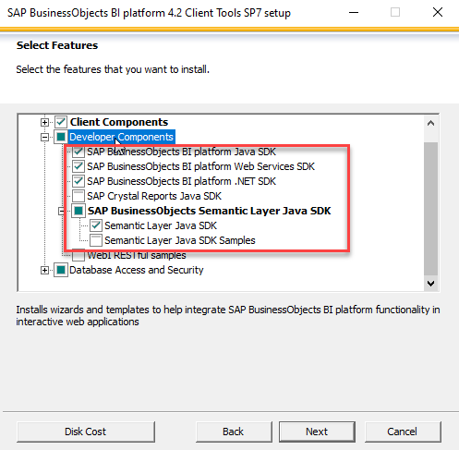

In the “Developer Components” WIP needs at least (else check all)
- SAP BusinessObjects BI platform Java SDK
- SAP BusinessObjects BI platform Web Services SDK
- SAP BusinessObjects BI platform .NET SDK
- SAP BusinessObjects Semantic Layer Java SDK/ Semantic Layer Java SDK

Database Access and Security
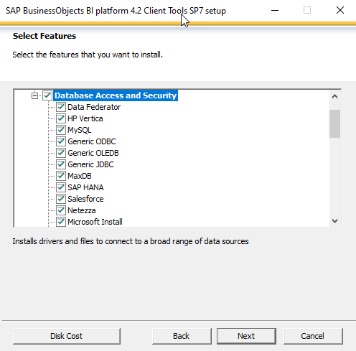
In the “Database Access and Security” select all items to ensure you have at least the same drivers you have on your clients and server installations

Configure SAP-BI Connector
Launch WIP Setup and go to the SAP BO Versions
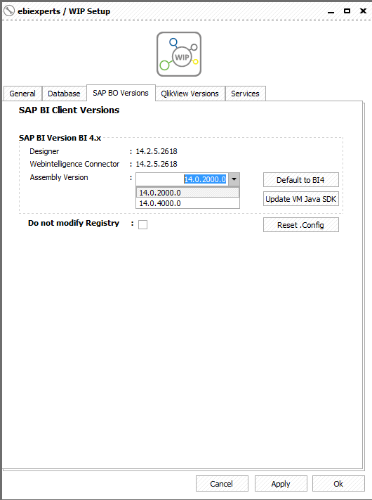
Versions: If you see Designer or Webi Connector version 14.2.5 mean BI4.2 and SP5
Assembly Version:
- for versions till 4.2SP5 included, select 14.0.2000.0
- for versions > 4.2SP5 select 14.0.5000.0
Update VM Java SDK: on 1st installation or if you change SAP-BI client version press this button to update WIP Java libraries. It’s important to do it

