QVAUctor ltd

Connect WIP to Qlik Sense Server
Installation Guidelines

CONFIGURATION MANAGEMENT
Author | Jean-Philippe Golay | Issue Date: | 11 November 2019

Table of Contents
1 Overview 2
1.1 Prerequisites 2
2 Link to a Qlik Sense Server 2
2.1.1 Export Qlik Sense Certificate 4
2.1.2 Import Qlik Sense Certificate in WIP 6
2.1.3 Test link to Qlik Sense server 6
2.1.4 Qlik Sense Enable Multiuser Checkout 7
2.1.5 Create Environments 7
2.1.6 Create a DEV-UAT-PRD Environment on one single Qlik Sense Server 8
2.1.7 Import Qlik Sense Users 9

Overview

Prerequisites
Please consult WIP Install Guide.pdf for prerequisites

Link to a Qlik Sense Server
Click “Create New Server” and select “Qlik Sense” to link to a Qlik Sense Server.
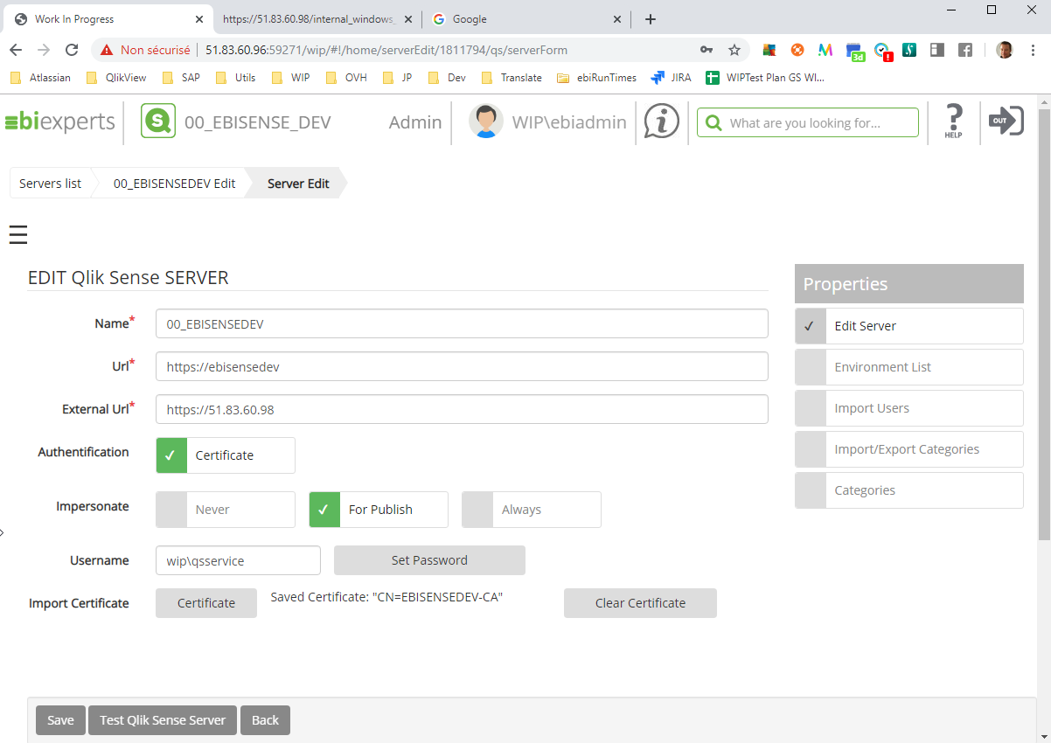

Name: WIP Name of this specific server.
URL: The Qlik Sense Server URL that WIP will connect to, generally in the intranet
External URL: The Qlik Sense Server URL the users will connect to
Ports: Ports 443 (https), 4242 and 4747 must be open between WIP Web Server and Qlik Sense Server to connect
Authentication: The method used to identify the user on the Qlik Sense Server. Currently WIP will connect using Certificates on port 4242 for QRS REST API and 4747 for .NET API bypassing the PROXY.
Impersonate:
- Never: will use Logon User for all actions,
- For publish: will use Logon User for all actions but server user for publish
- Always: will use server user for all actions

Import Certificate: See below
Click “Test Qlik Sense Server” to validate the server connection.

Open firewall ports

Ports: Ports 443 (https), 4242 and 4747 must be open between WIP Web Server and Qlik Sense Server to connect
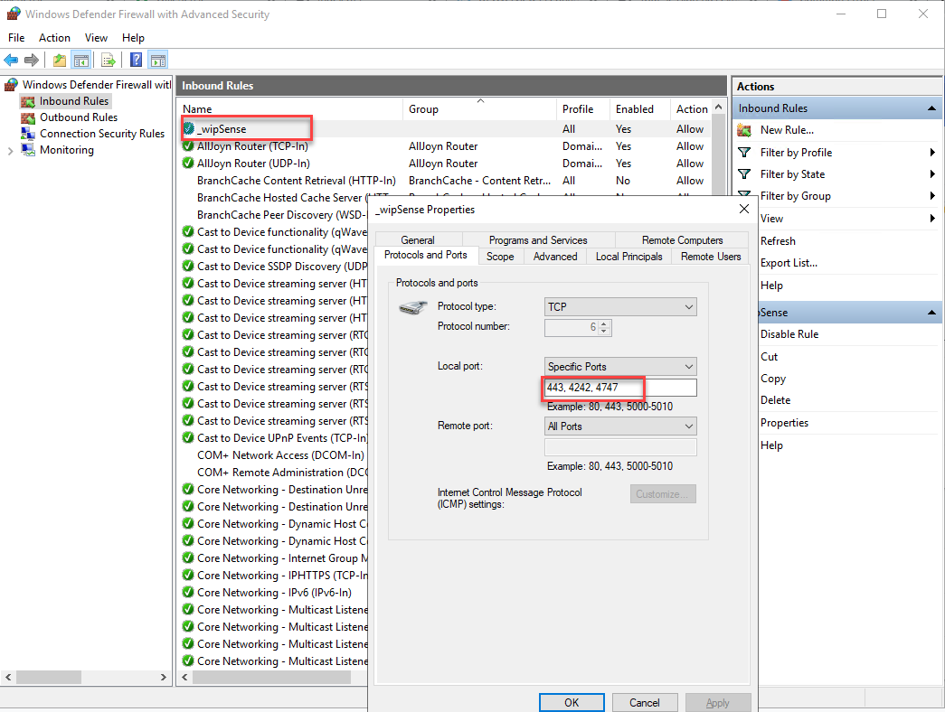

Export Qlik Sense Certificate

Go to the QMC and choose the certificate menu, enter a machine name and press export
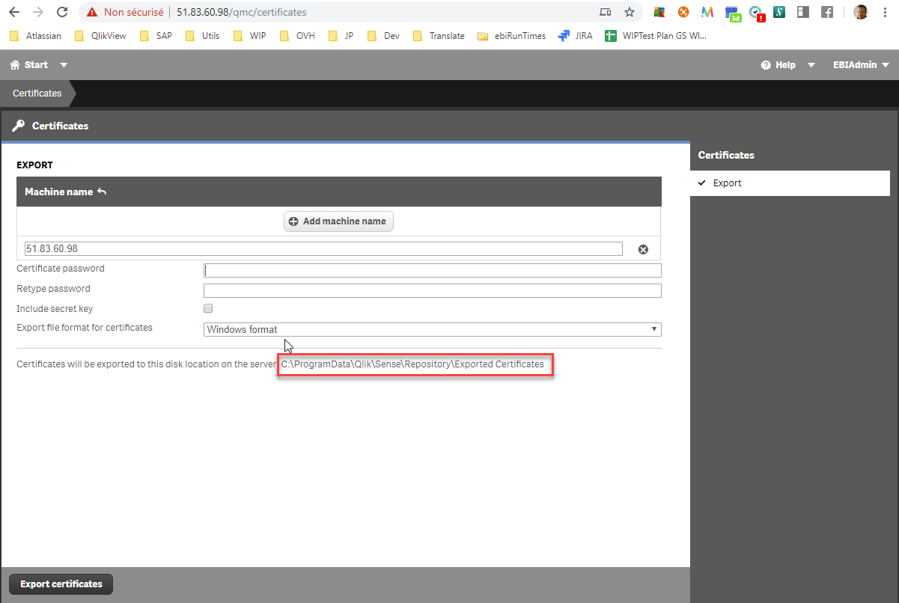
Certificates will be exported in the
“C:\ProgramData\Qlik\Sense\Repository\Exported Certificates“
folder. Note that if you have multiple nodes it can be on any of them.

Import Qlik Sense Certificate in WIP
Back in WIP Press the “Certificate” button select your exported client.pfx, Open
In WIP Press “Save” button
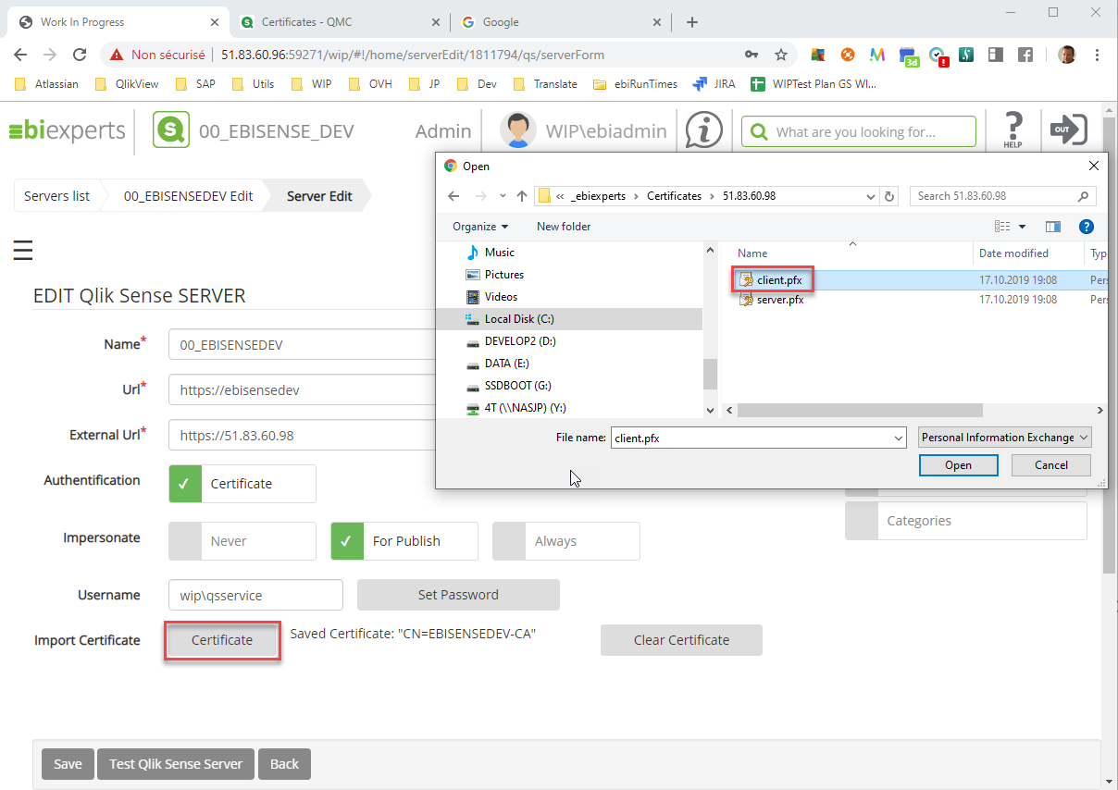

Test link to Qlik Sense server
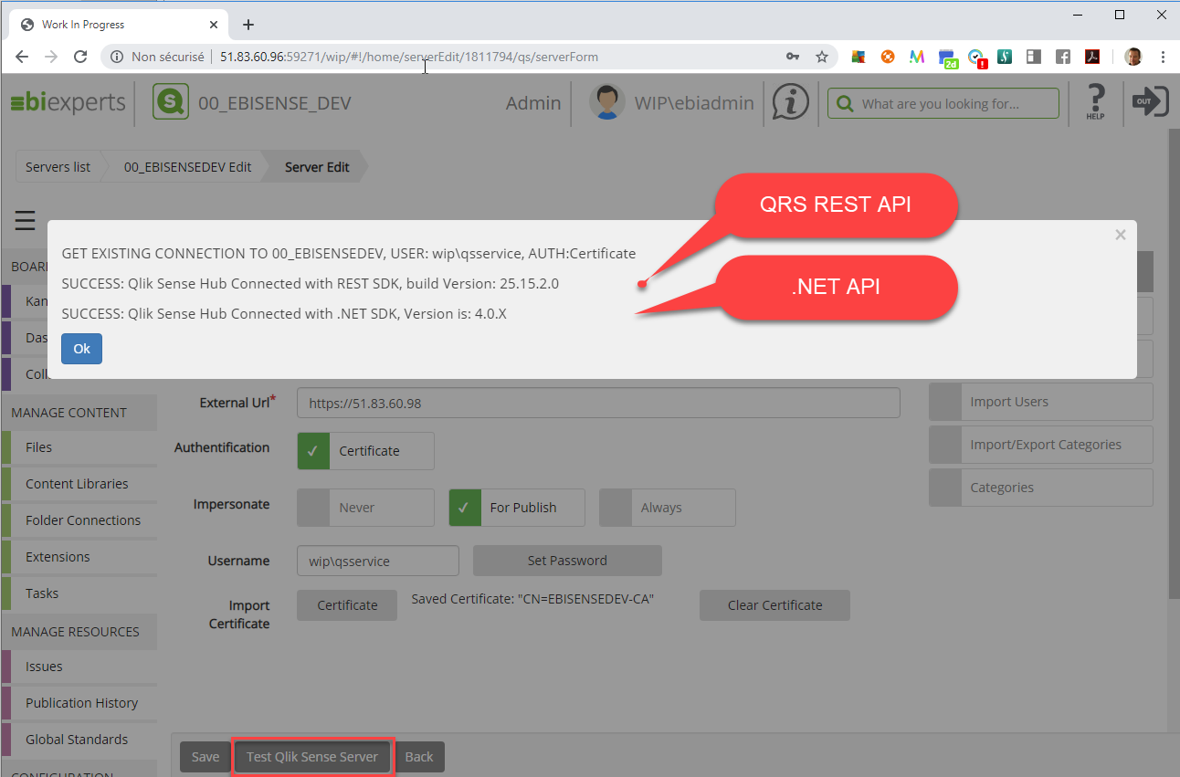

Qlik Sense Enable Multiuser Checkout
From sense November 2018 you need to make this manipulation in order to allow Qlik Sense App sharing
- Edit “C:\Program Files\Qlik\Sense\ServiceDispatcher\services.conf” (or the equivalent path if you chose a non-default install location)
- Search for the section [hub.parameters]
- In that section add --enable-non-published-sharing
- Restart the Qlik Sense Service Dispatcher
- Restart Qlik sense server if it doesn’t work
- Repeat on each node in the deployment

Create Environments
When you create the Qlik Sense server, WIP creates an environment by default with same name that the server.
You can create multiple environments in a single Qlik Sense server see the chapter Create a DEV-UAT-PRD Environment on one single Qlik Sense Server
Refers to WIP Admin Guide to create new environment.
Note: ensure you add Administrators Group to the security else you will not be able to see it.
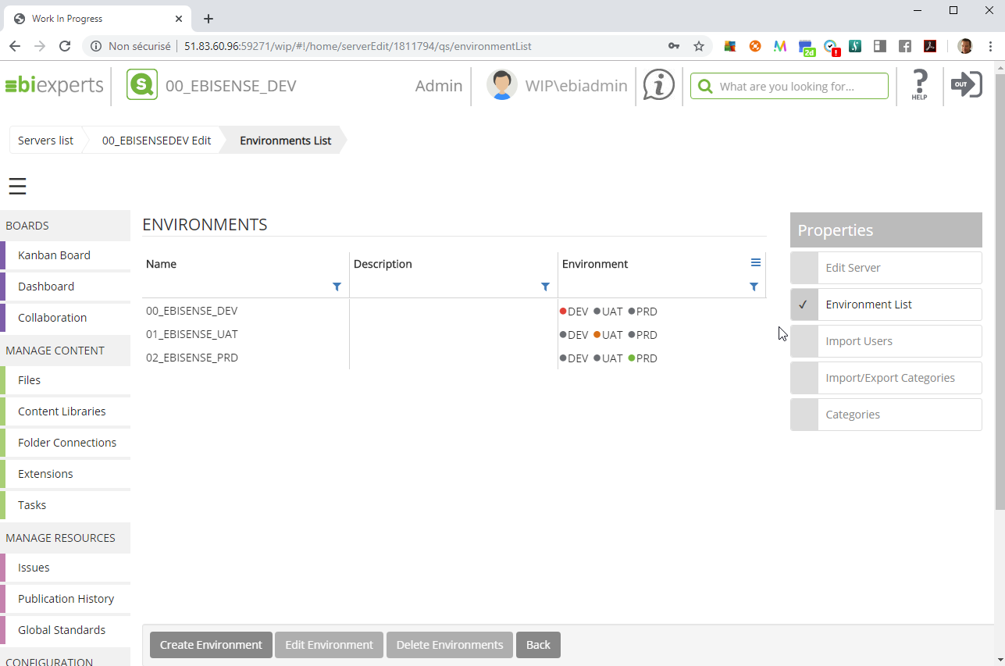

Create a DEV-UAT-PRD Environment on one single Qlik Sense Server
With WIP you can create a multiple environments infrastructure in a single Qlik Sense server. You will log on against DEV environment to make your check out / check in to “My Work”, then create a set of streams for UAT and PRD.
Example:
In WIP create 00_EBISENSE_DEV, 01_EBISENSE_UAT and 02_EBISENSE_PRD environments.
Create departments or feature folders in WIP like “Finance”
In Qlik Sense create finance_DEV, finance_UAT, finance (PRD) streams
Select WIP Finance folder and assign the respective streams in the Destinations
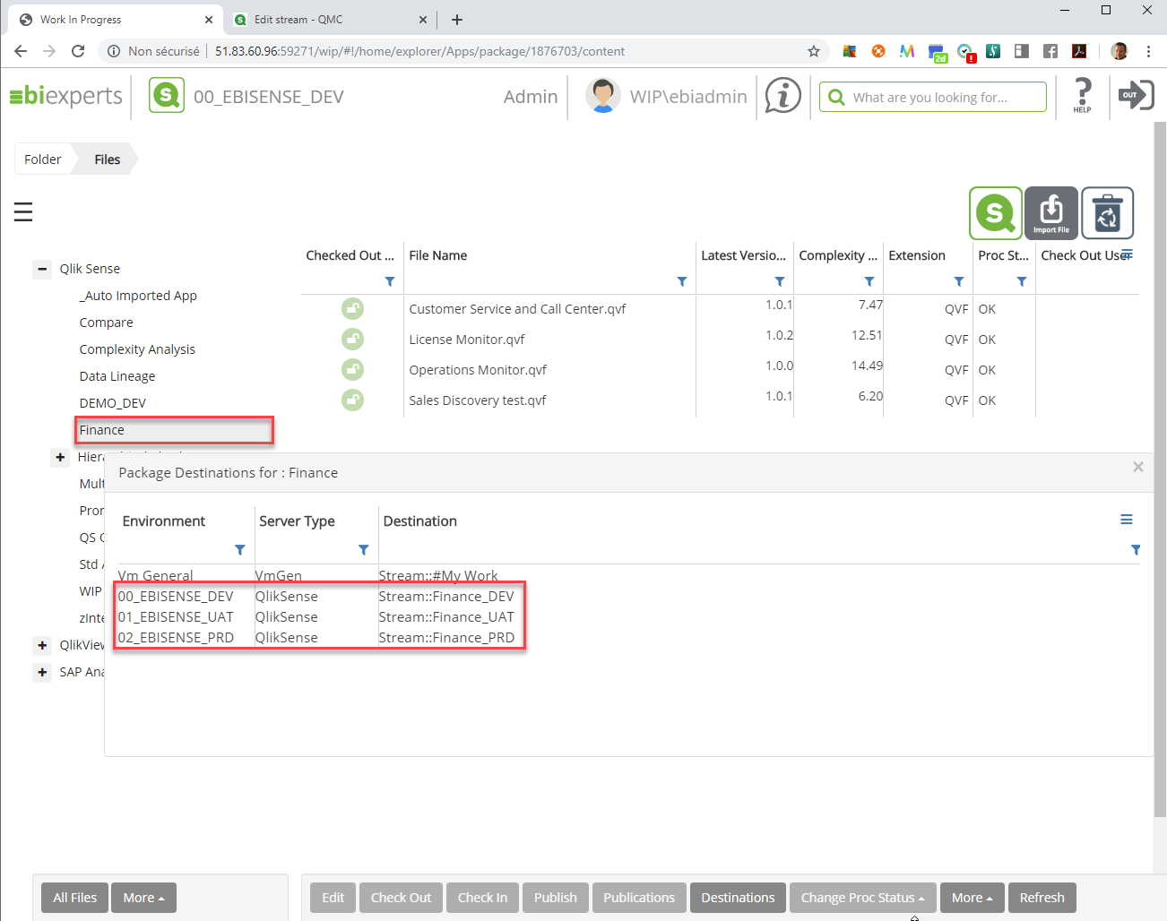

Import Qlik Sense Users
WIP can import the users from Qlik Sense Repository.
Only users not already in WIP will be displayed.
Note: that on first import user information in WIP is not filled.
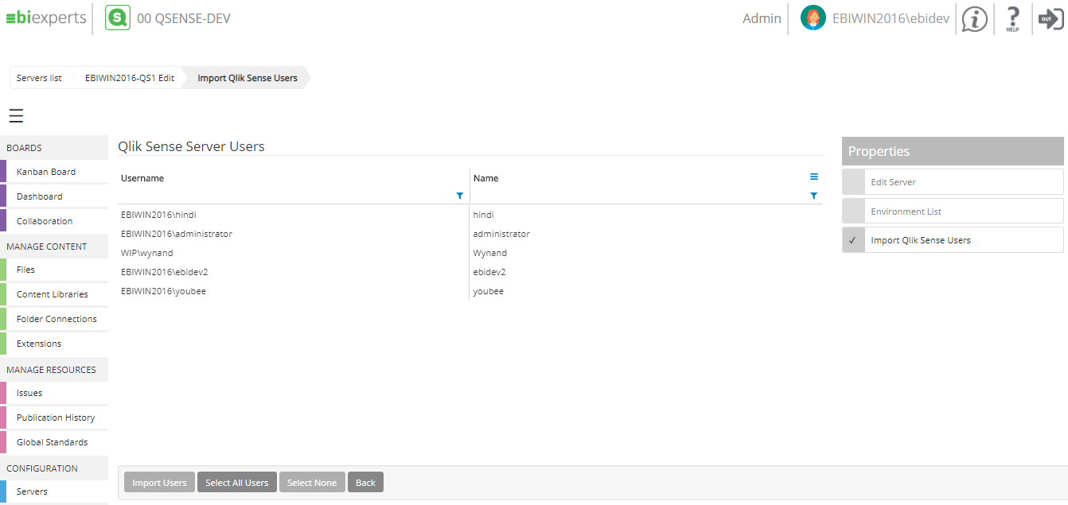

Setup SAML Authentication
WIP can use SAML connectivity using Qlik Sense proxy. WIP will authenticate your users redirecting to the virtual proxy that will login the user and callback WIP for login process.
Any kind of Qlik Sense authentication is supported like AD, Azure, Okta, custom forms…
All you need to do is enter the proxy address to use in the Url field
- If you want to use the Qlik Sense default proxy put blank proxy
  - https://qliksense/
- If you want to use a proxy (Azure, Okta, AD, Form…) add the proxy at the end of the Url
  - https://qliksense/virtproxy/
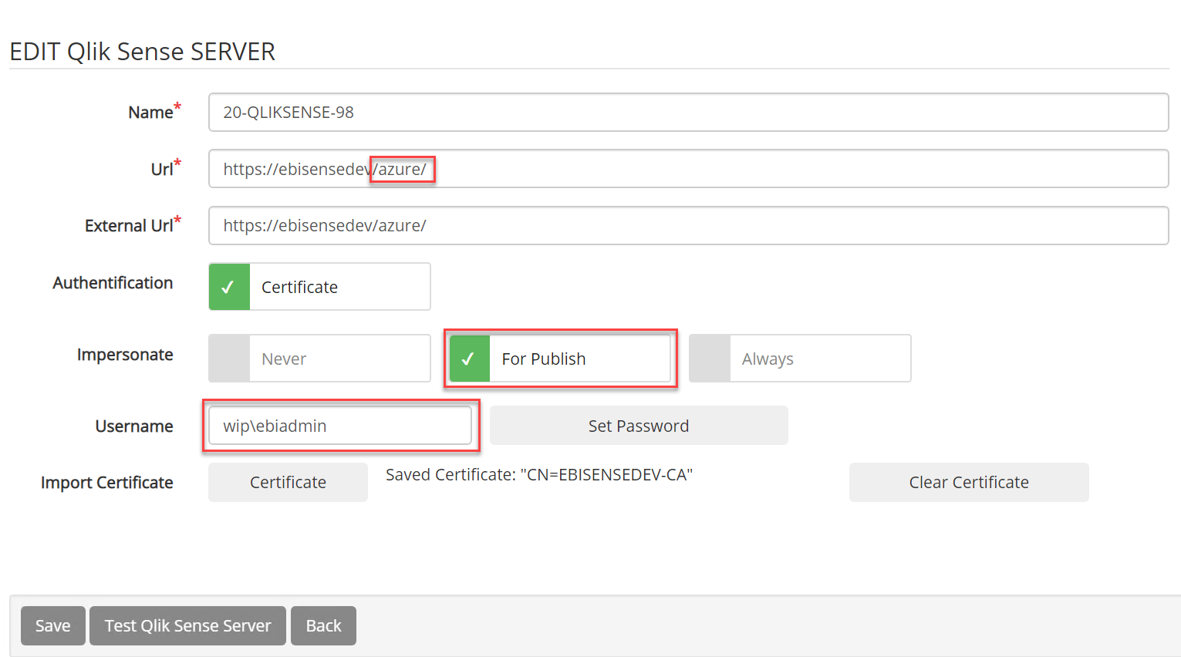
You need to set impersonate “For Publish” and set a Username and Password as WIP don’t know your username on first login
Then in login form choose Qlik Sense for login mode, you will be redirected to Qlik Sense Authentication
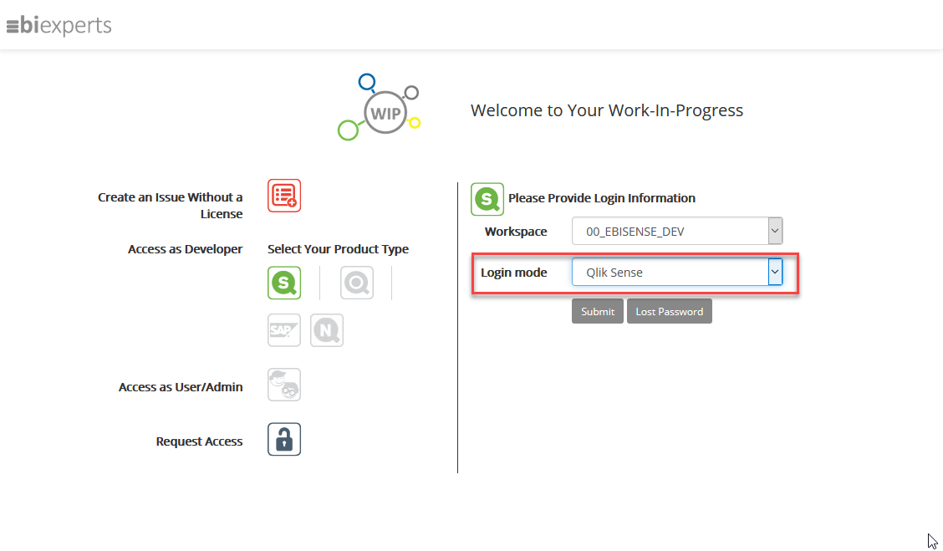
Proceed to Qlik Sense authentication (Azure in that case but can be any authentication you have defined in the Qlik Sense Proxy)
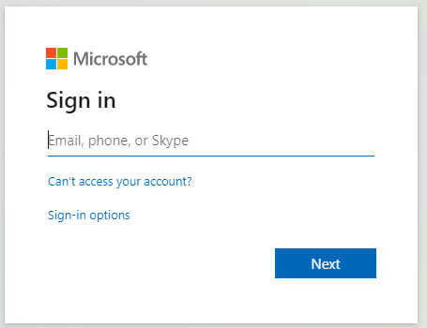
On first registration WIP will create your user in the repository but an administrator need to validate it and assign you a WIP License. If no license assigned or user is not already validated you should receive a message like this:
User XXX.onmicrosoft.com not active or not yet validated please contact your administrator"

To validate you user Administrator must login select Users, and check the “Validation Required”
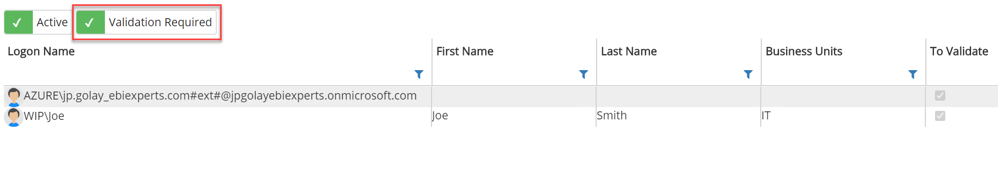
Uncheck the Validate User
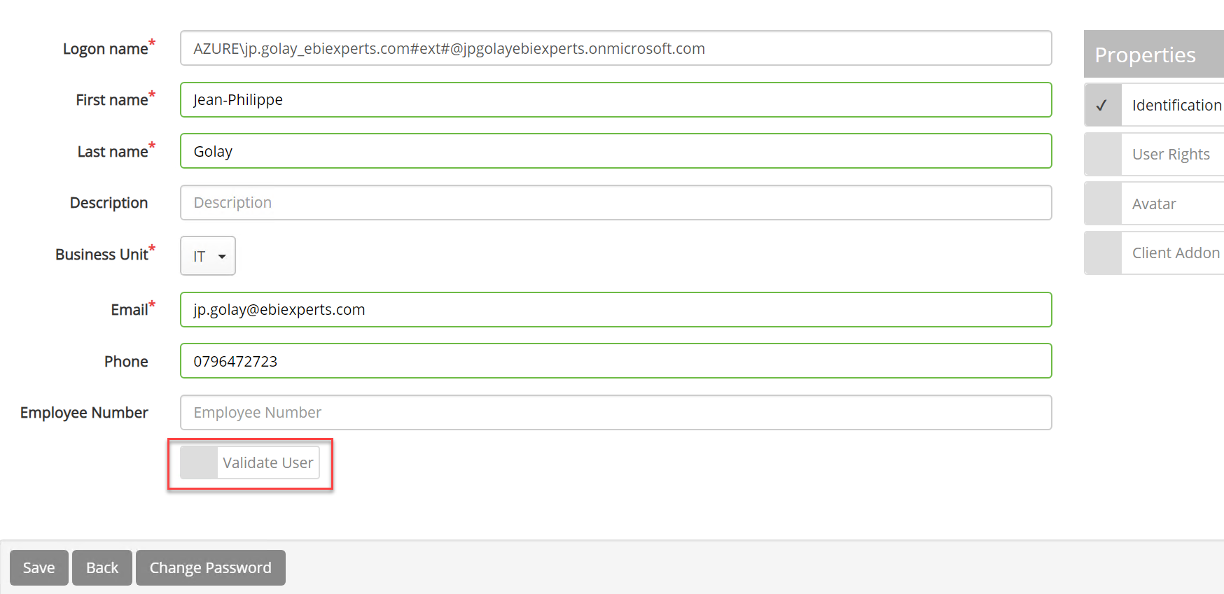
Assign you a license and a Group
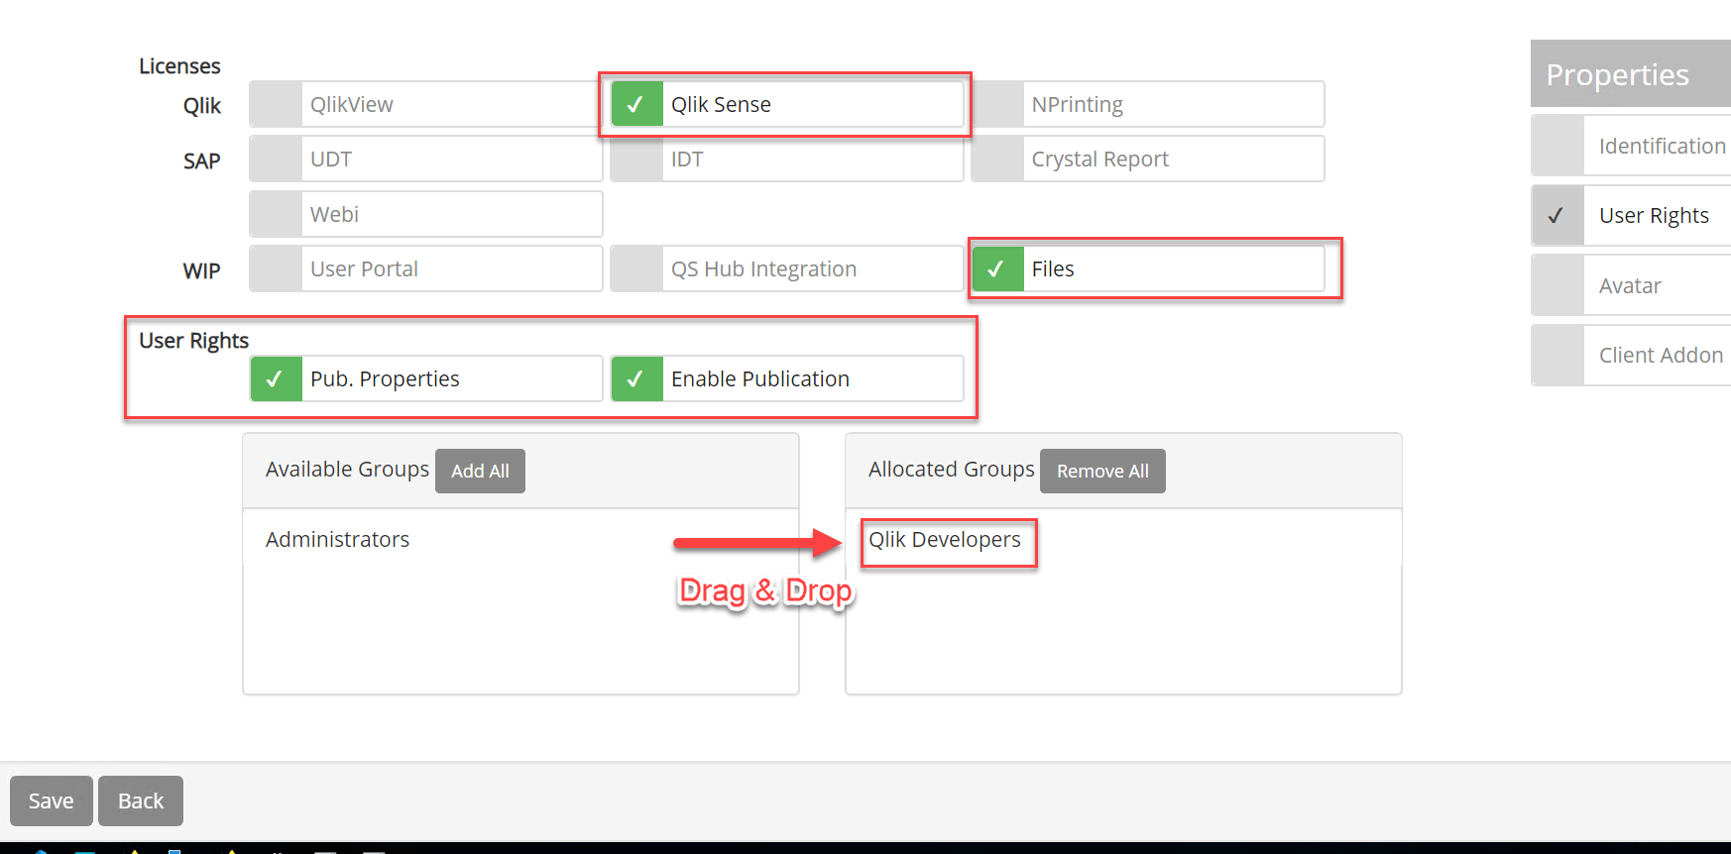
That’s all you should be able to login using Qlik Sense SAML

Setup Qlik Sense Load Balancing

