QVAUctor ltd

Connect WIP to QlikView Server
Installation Guidelines

CONFIGURATION MANAGEMENT
Doc ID: | WIP Connect to QlikView Server
Author: | Golay Jean-Philippe | Issue Date: | 04 November 2019

Table of Contents
1 Overview 2
1.1 Prerequisites 2
2 Installing WIP for QlikView 2
2.1 WIP for QlikView User’s Impersonation 2
2.1.1 WIP for QlikView Security 2
2.2 Install and configure QlikView Desktop 6
2.3 Assign a License QlikView Desktop 6
2.3.1 Assign a QlikView Server License 7
2.3.2 Assign a QlikView License Key 9
2.4 10
2.5 Install WIP 10
2.5.1 Installation 11
2.6 Launch WIP Setup 14
2.6.1 Check the WIP Web Server Service Credentials 21
2.6.2 Check the WIP Web Server Service User’s Authorizations 22
2.6.3 Check that all users that will log into WIP can login to this machine 23
2.7 Testing WIP for QlikView 24
2.7.1 Enter WIP License 24
2.7.2 Create a New QlikView Server 26
2.7.3 Test WIP QlikView Server 27
3 WIP configure Reload with QlikView Publisher 28
3.1 Activate the Publisher reloads 28
3.2 How to export the QMS certificate 29

Overview

Prerequisites

Please consult WIP Install Guide.pdf for prerequisites

Installing WIP for QlikView
This is a special chapter for WIP for QlikView installation, as QlikView is an old desktop technology it requires a little more configuration.
Related documentation: see this training video
WIP Training 03 Connect QlikView Server

WIP for QlikView User’s Impersonation

WIP for QlikView Security
- As WIP is a Web Server it’s the user starting the service (WIP Service User) will interact with database and launch QlikView sessions
- In order respect Windows user’s security WIP Web Server will impersonate (create a local windows session) on belong of the <WIP Log On> user or the WIP Proxy user. The proxy user is the user defined in the QlikView Server.
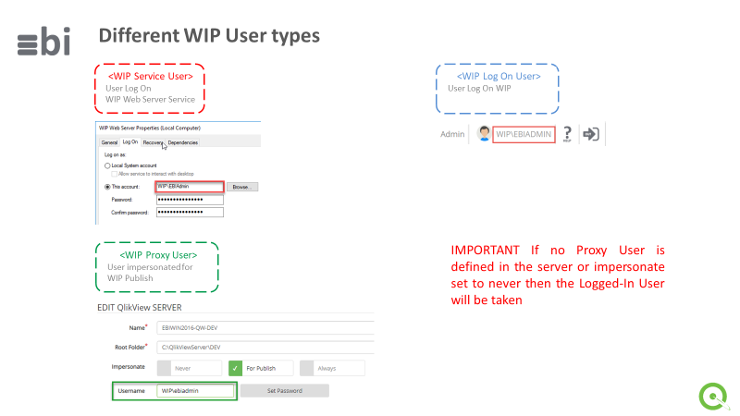

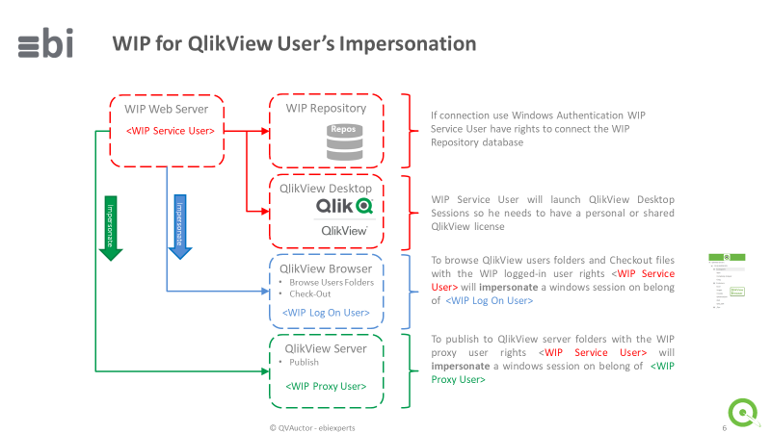

Impersonation
- As WIP service is running with the WIP Service User credentials in order to browse logged-in user folders with the correct credentials, WIP Service User must have the right to create a windows session in behalf of the logged-in user (Impersonate)
https://docs.microsoft.com/en-us/windows/security/threat-protection/security-policy-settings/impersonate-a-client-after-authentication
Also, the user being impersonated must have the right to logon locally on the windows server where WIP is installed.
https://docs.microsoft.com/en-us/windows/security/threat-protection/security-policy-settings/allow-log-on-locally

Browse QlikView Servers
- The QlikView Server browsing is done using the <WIP Log On> User he must have Read right on Qlik View Server shares and folders defined in WIP QlikView Server
Checkout
- The checkout is done using <WIP Log On> User and this user must have Windows AD RW right on destination checkout path.
- If you want the WIP Web Server to checkout to your local machine install the WIP Addon and prefix the Destination path by «@» (@C:\QlikViewApps)
Publish
- The QlikView Server publish is done using <WIP Proxy User>. If no <WIP Proxy User> is defined then WIP will use <WIP Log On>. <WIP Proxy User> or <WIP Log On> must have WRITE and CREATE FOLDER right on publish destinations shares or folders.

User’s Rights for <WIP Service User>

These are the user’s rights necessary for WIP Service User
- Belong to Administrators Group
- Have RWCD rights on the database in integrated authentication is used
- Local Security Policy
  - Access this computer from the network
  - Act as part of the operating system (can be necessary to launch QlikView Sessions)
  - Allow log on locally
  - Logon as a service
  - Log on as a batch job
  - Impersonate a client after authentication

User’s Rights for <WIP Log On> User

In order to be impersonated a QlikView user need to be allowed to logon locally
To check this launch to C:\Program Files\QlikView\Qv.exe
Press Shift+Right Click / Run as a different user and enter the user’s credentials
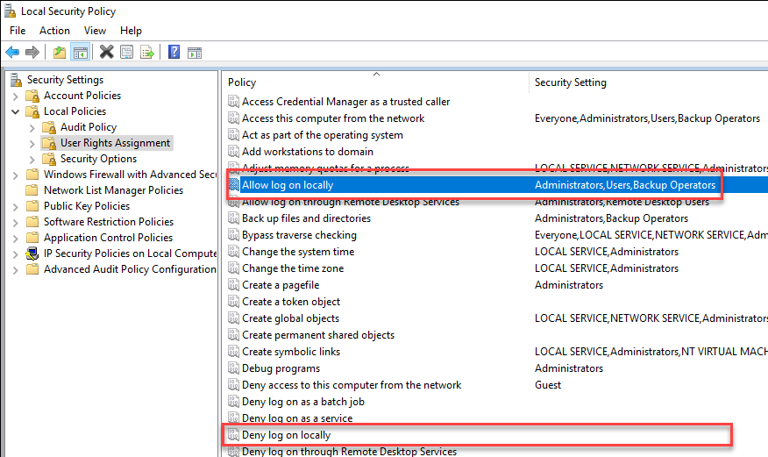

Install and configure QlikView Desktop
Install QlikView Desktop version 12 and Later

Assign a License QlikView Desktop
QlikView Desktop must be assigned a license for the user that starts the WIP Web Server Service. It’s very important, failing to license this user will result to check-in errors.
With the file explorer go to C:\Program Files\QlikView
Search Qv.exe
Press Shift-Right Click Run as different user
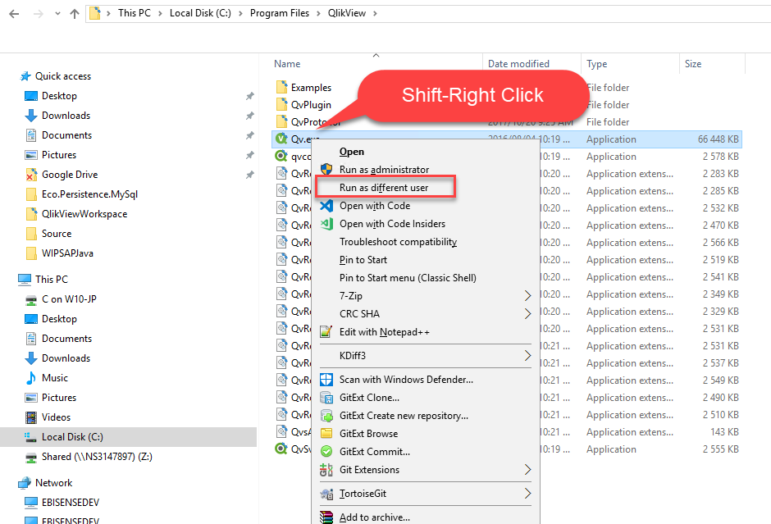

Enter the same user’s credentials that you used to start the WIP Web Server Service
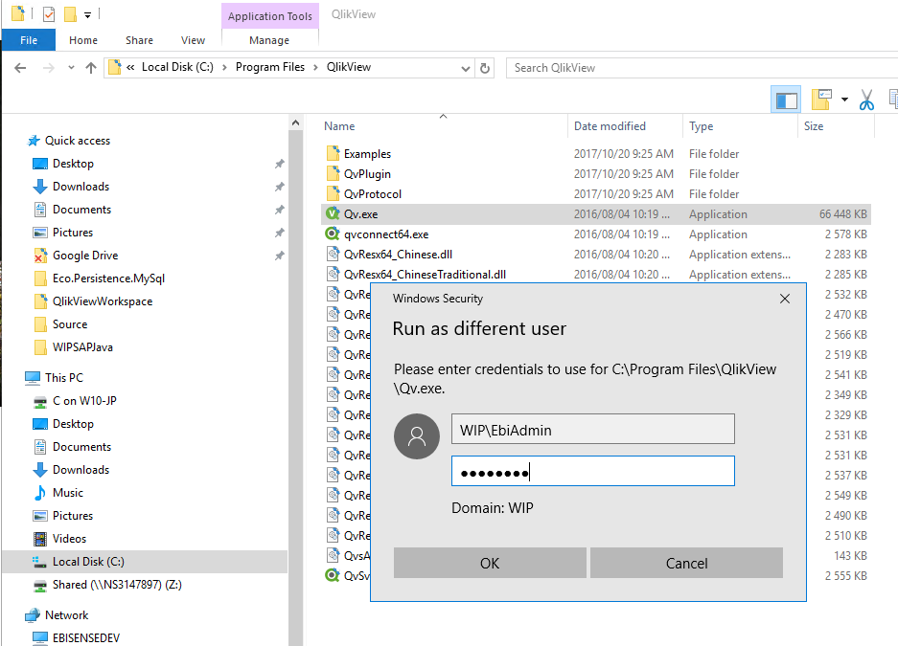

Assign a QlikView Server License
In QlikView press File / Open In Server
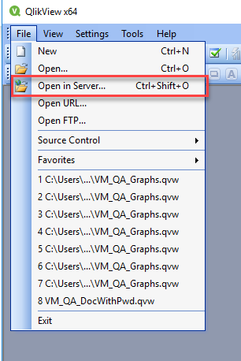

Type the QlikView Server url like qvp://<url>
Then press Connect will assign a license. It’s the best way to assign a license it as if license expires it will fetch a new one
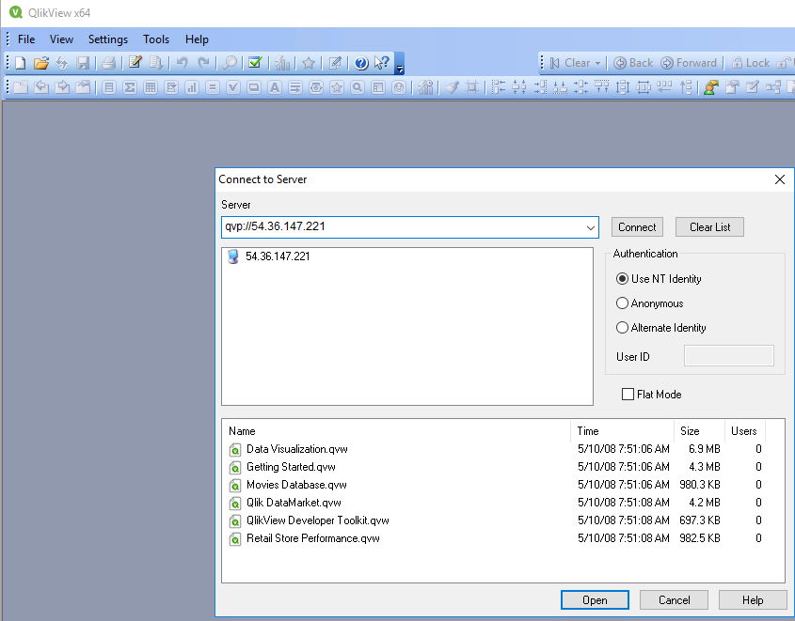

Assign a QlikView License Key
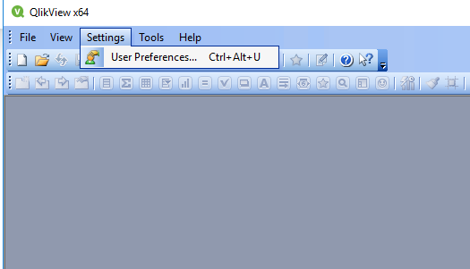
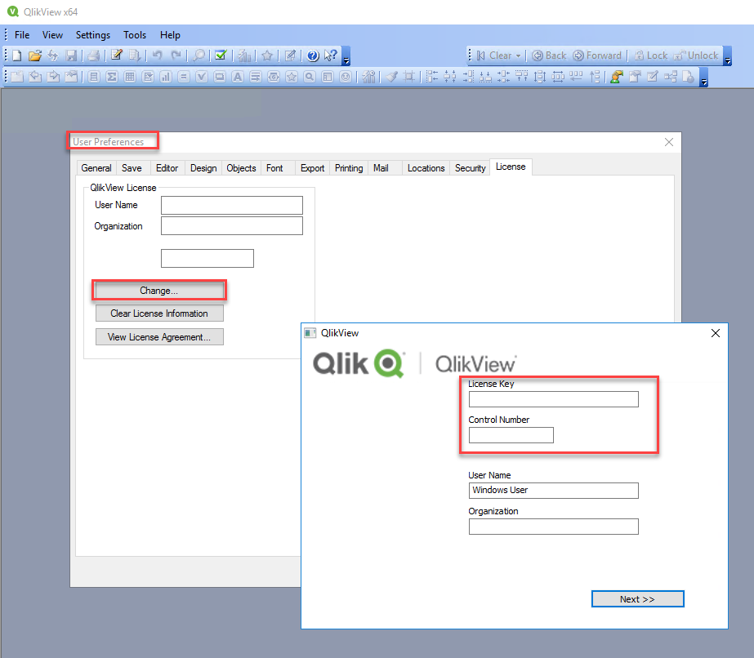

Install WIP
Ask us for the link to our Google Drive or FTP
Under the WIP folder you will find official releases
Under dailybuild you can find your Service Pack. Only install from that folder if instructed by ebiexperts.
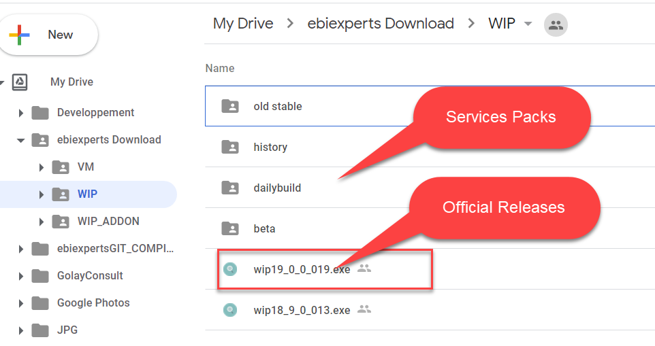

Installation
Launch WIP Installer
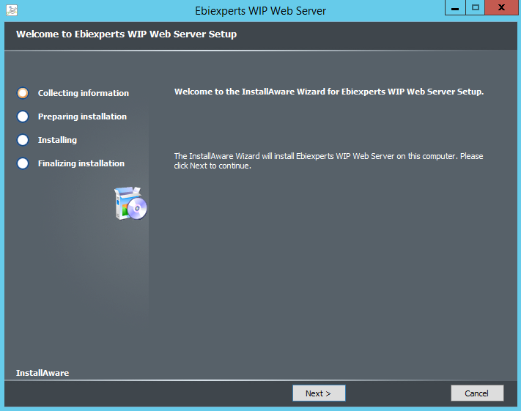
Select Complete Setup and click Next.

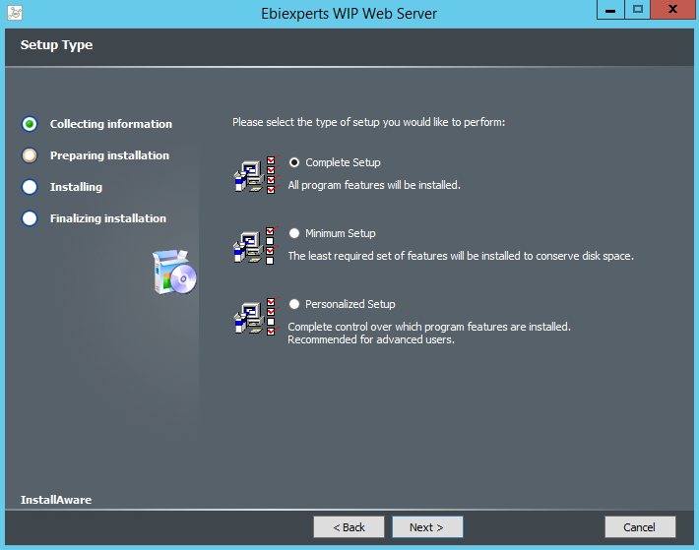

- You will be required to input the credentials of the Service User that will launch WIP Web Server. This user needs to be an Administrator of the machine, the password is required as this user will be used to start the WIP service.
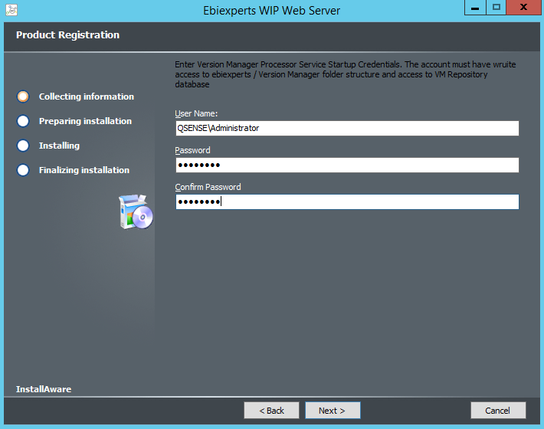

- The installation is now ready to start, click Next to start.
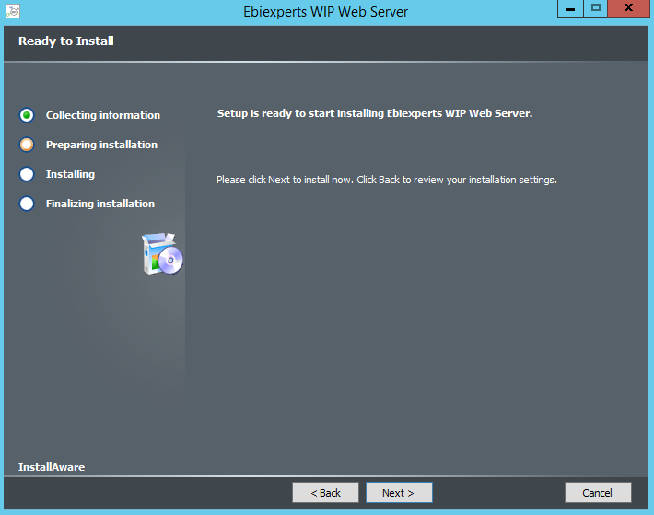

- When the installation is completed, leave the checkbox ticked to immediately launch WIP. This will launch the WIP Setup where you will configure your WIP Server to your database repository.
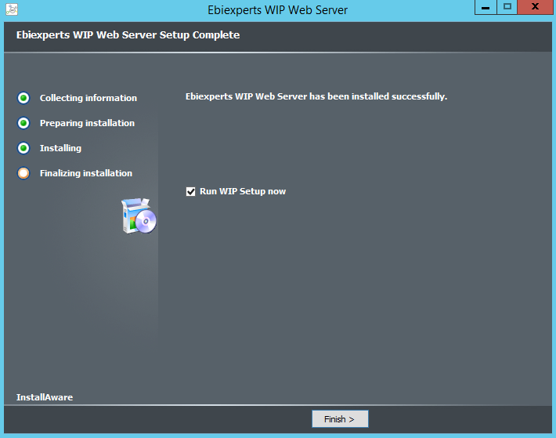

Launch WIP Setup

If you are logged in Windows with the WIP Web Service user launch WIP Setup from start menu
Else if you are not logged in Windows with the WIP Web Service user entered in the WIP Installed and want to connect the repository database with windows integrated security locate
C:\ProgramData\ebiexperts\WIP Web Server\webapp\WIPSetup.exe
and run it as same user than the WIP Web Server Service User to have the same database credentials
Press Shift – Right Click on VmCcNETSetup.exe
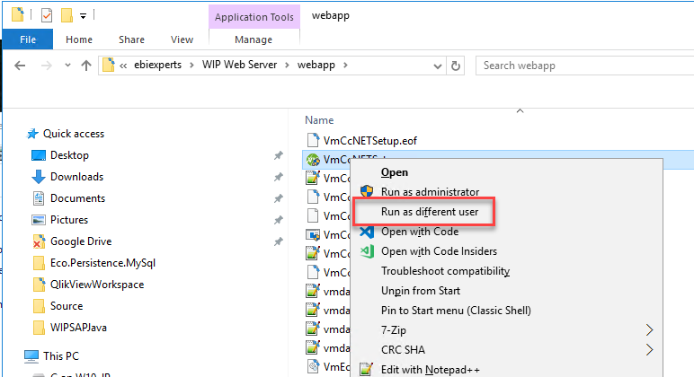

Once in VmSetup
Refers to WIP Install Guide “10 INSTALL / UPDATE WIP REPOSITORY DATABASE” chapter to connect the database.
In short for SQLServer select OLEDB SQLServer and press the “…” button right to Database Connection
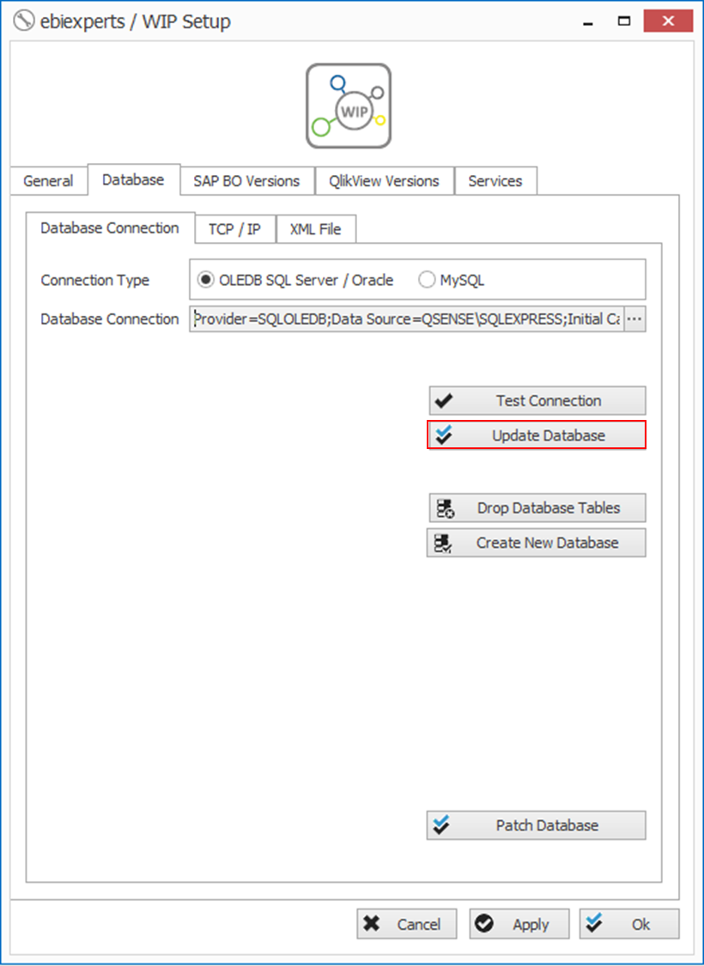

Enter your connection Server and select Database then press Test Connection

Remark: as you see if you “Use Windows Authentication” the Logon User will connect the database. So in order to use same WIP Web Server Service user credentials
- Logon Windows as WIP Web Server Service User
- Rus WIPSetup.exe as WIP Web Server Service User

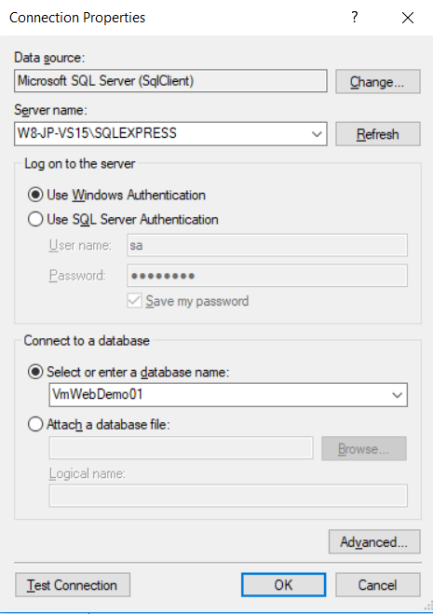

Back in the Database tab press Update Database.
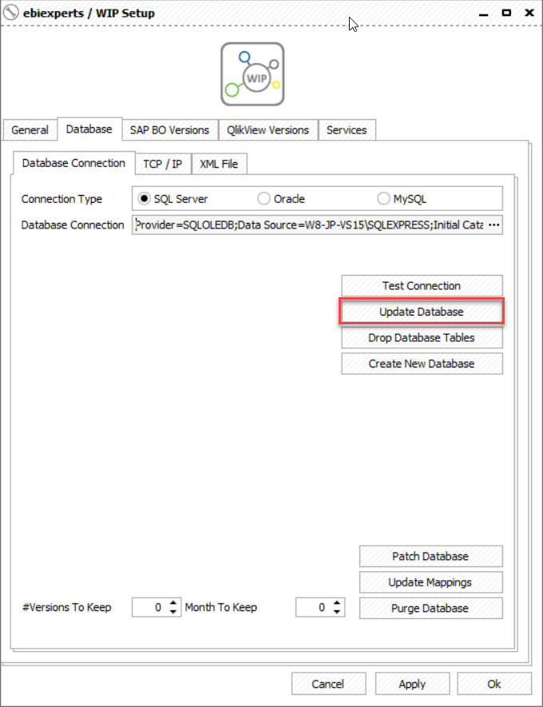

Go Back to WIP Setup select the QlikView Versions, click on Default to QV12 and press the Launch Default QV, should launch QlikView

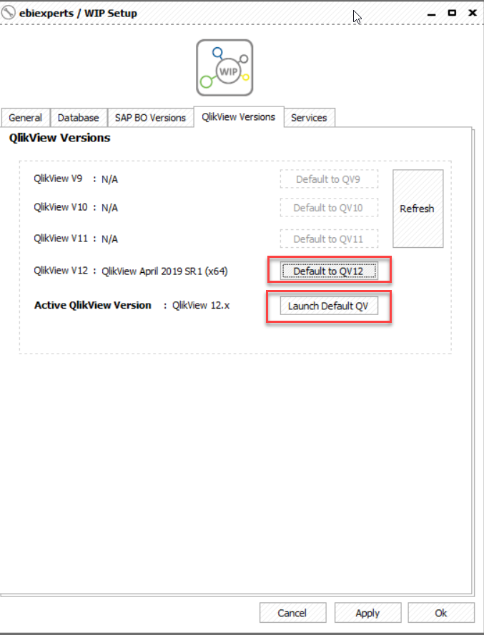

Double check that QlikView is not in Personal Edition in the Windows Title
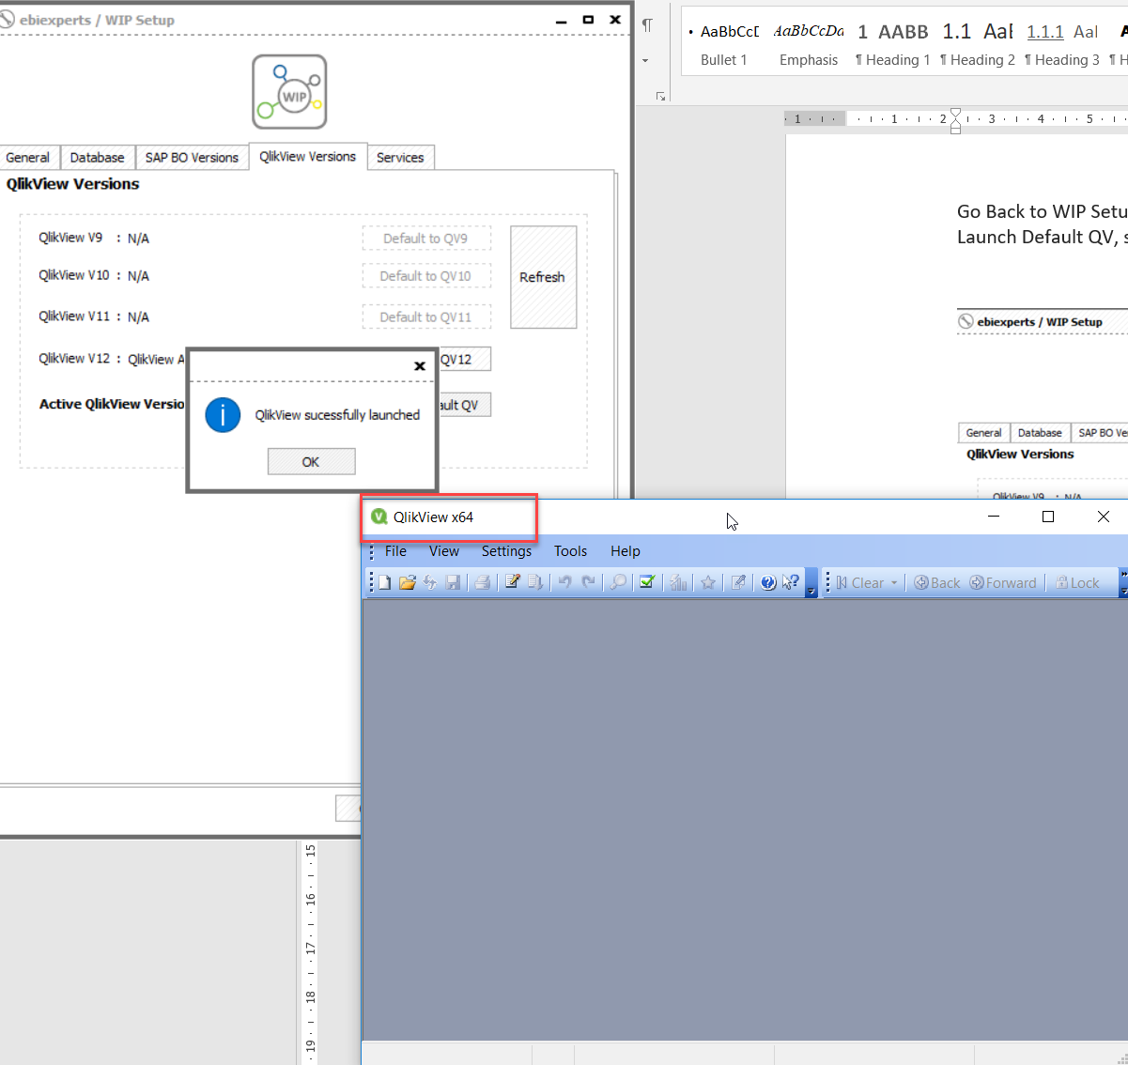

Go to the Services Tab and check that the WIP Web Server is started
More details on WIP Web Server Configuration is available in WIP Install Guide in chapter “WIP Services”
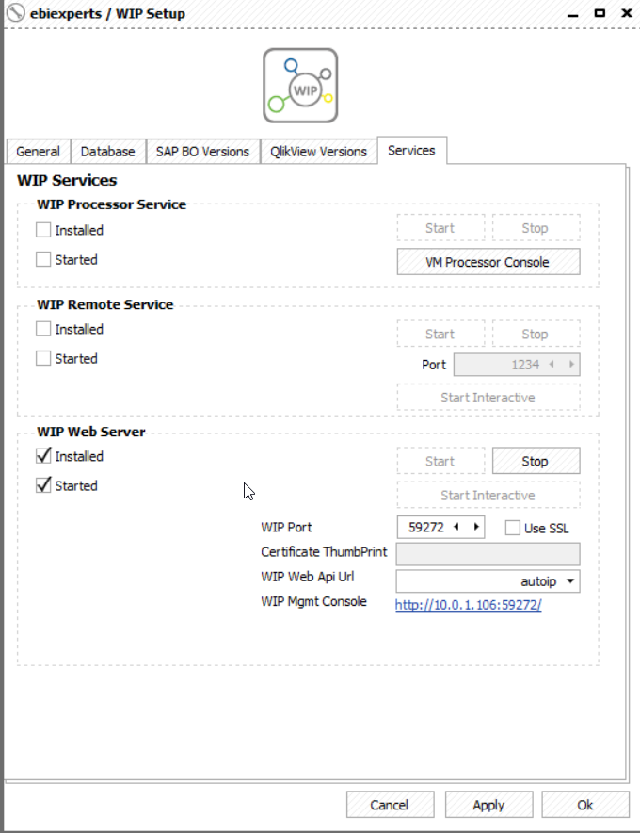

Check the WIP Web Server Service Credentials
Run services.msc check the login account is correct should have access to the database if using Integrated SQLServer Security and start the service. (Restart it if you change something)
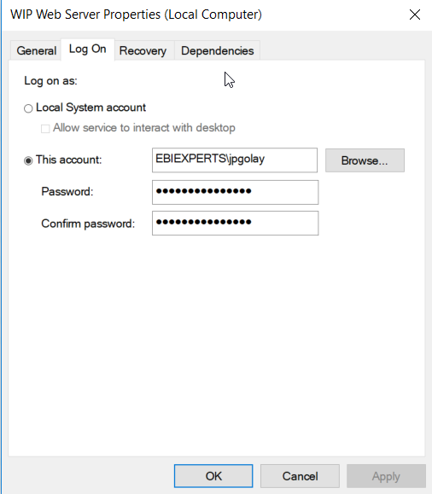

Check the WIP Web Server Service User’s Authorizations
Do this only if your WIP WebServer Service User is not part of the Administrators Group
In Start Menu Search for “Local Security Policy”
Security Settings / Local Policies / User Rights Assignment and add WIP Service User to
- “Impersonate a client after authentication”
- “Logon as a service”
- “Act as part of the operating system”
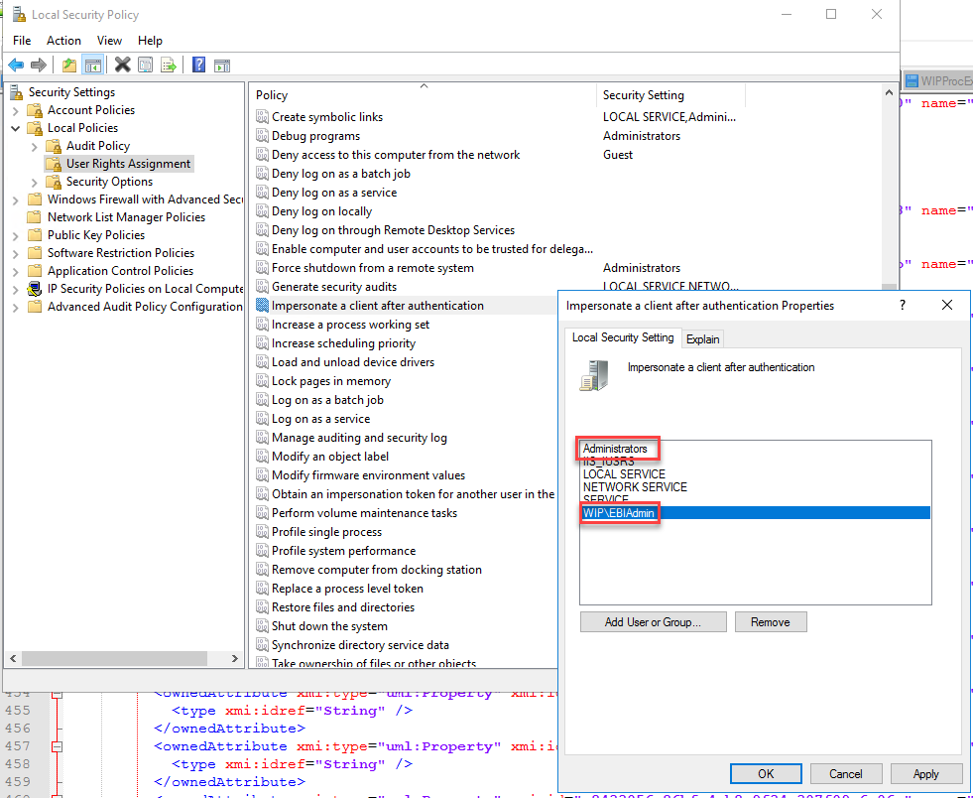

Check that all users that will log into WIP can login to this machine
All users that will Use WIP for QlikView must have the right to login the Windows machine where WIP Web Server is installed in order to be Impersonated by the WIP Service User
Locate
C:\ProgramData\ebiexperts\WIP Web Server\webapp\WIPSetup.exe
and run it as same user than the WIP Web Server Service User to have the same database credentials
Press Shift – Right Click on WIPSetup.exe
Run as different user and enter your user credentials. If it fails or your user have not the rights to “impersonate a user after authentication” or the user have not the right to logon to this machine, see with your administrator

Testing WIP for QlikView

Enter WIP License
Launch WIP (http://wipwevserver:59272/wip)
Login with VMMANAGER / EBIEXPERTS
If no license has been entered a license form will be shown. If an expired license is detected or you need to update it follow these steps
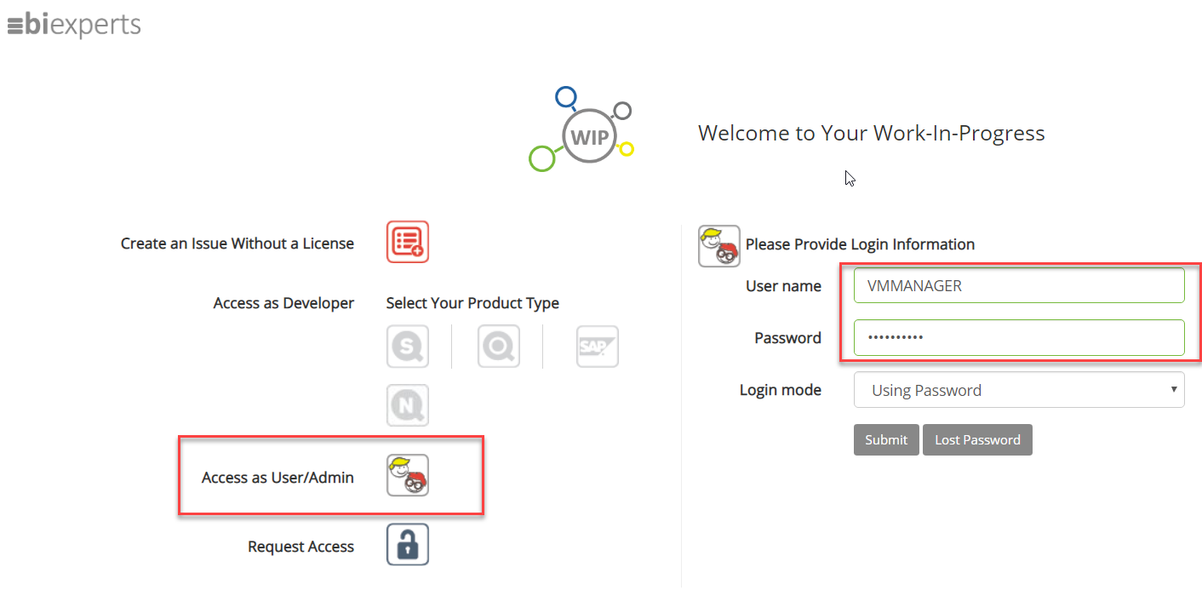

Enter your license in Options / License and check that you have a WIP QlikView User License
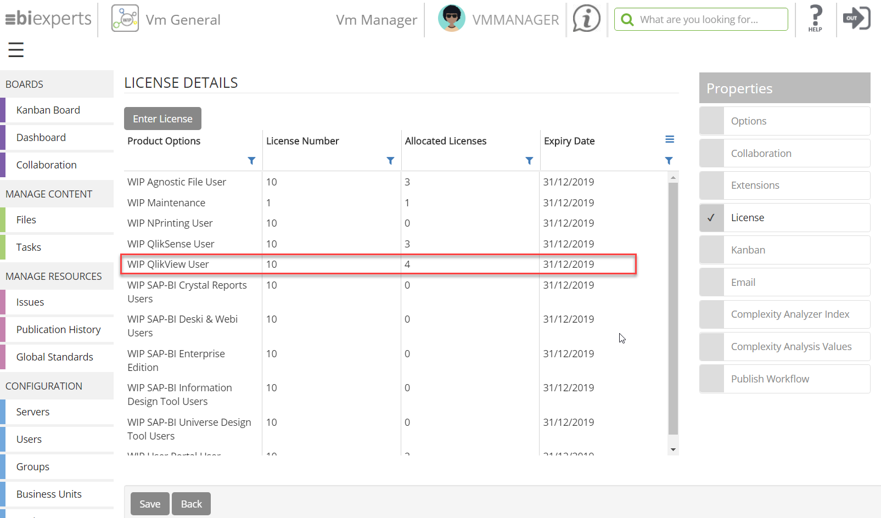

Create a New QlikView Server
Go to Servers + Create New Server / QlikView
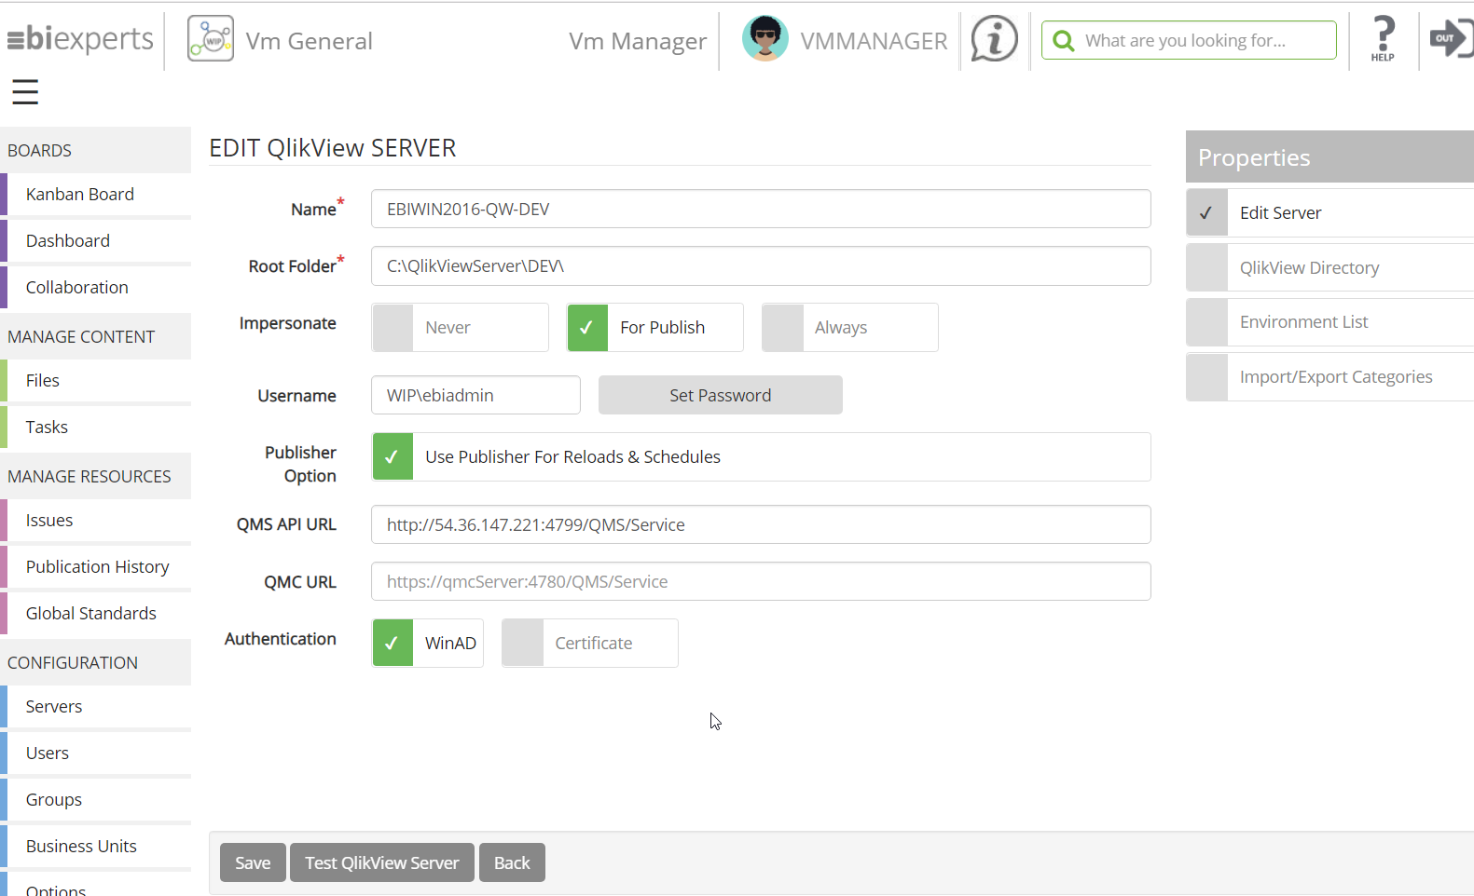
Name: WIP Name of your QlikView Server
Root Folder: Root folder where you will publish your QlikView applications. You can define supplementary folders (Mount) in QlikView Directory option
Impersonate: Set for Publish, Mean that Logged-In user will browse your QlikView servers and the proxy user (WIP\ebiadmin) will be used for publish in that server.
Username / Set Password: The Proxy User as defined in Impersonate
Publisher Option: If you have a QlikView Server or Publisher enter it’s URL in the form http://<qvserver>:4799/QMS/Service it will be used for reloads and QlikView desktop licenses upload
Authentication: WinAD if the QlikView server is not using https, certificate else. See the WIP Installation Guide to see how to import the certificates.

Test WIP QlikView Server
Once QlikView Server created press Save
Then Test
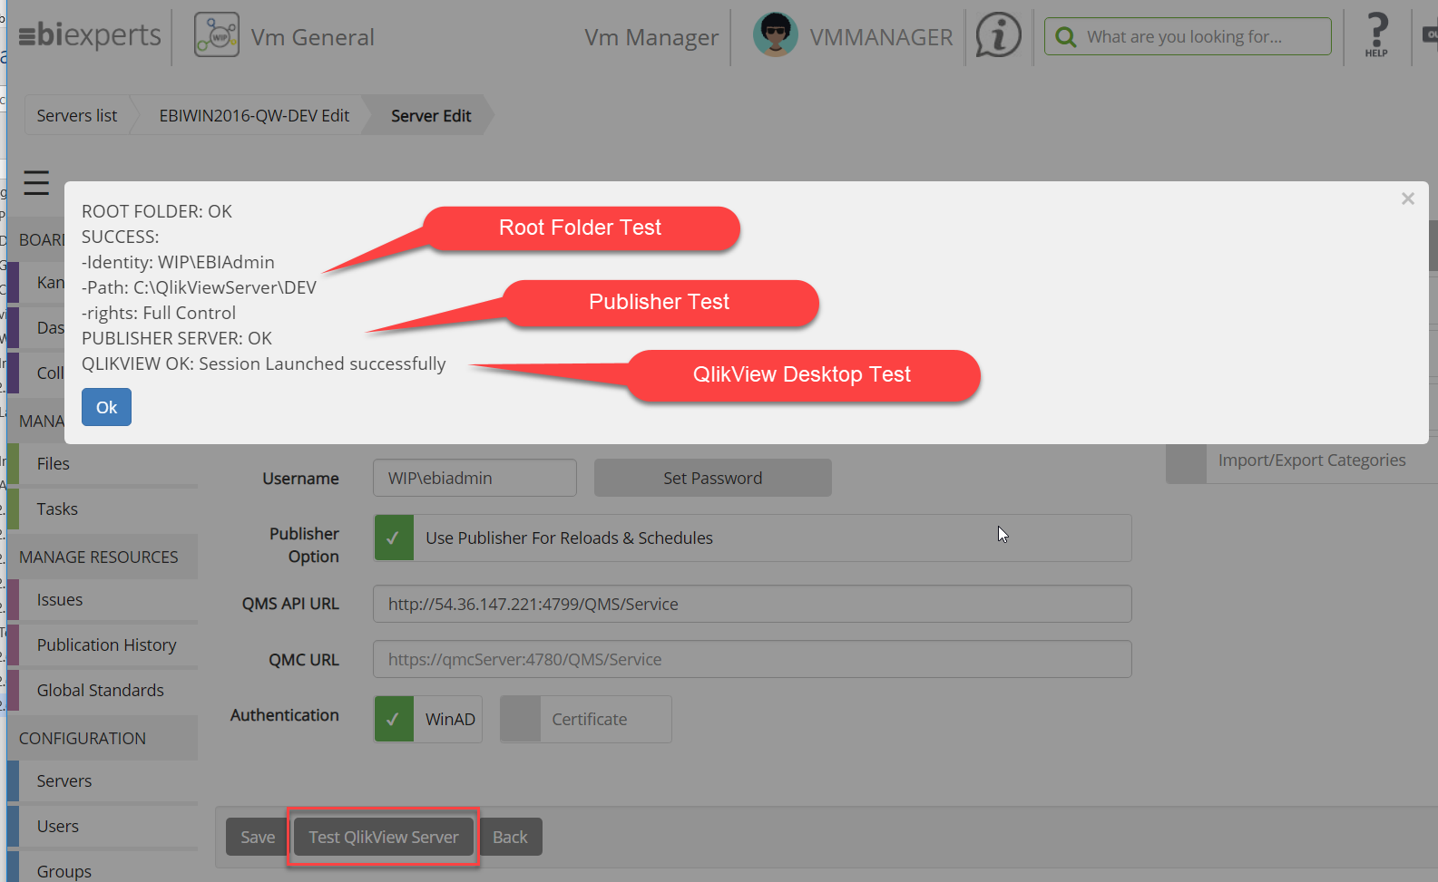
- WIP will test impersonation of the Proxy User (WIP\ebiadmin) by the WIP WebServer User (NOTE you can change the proxy user temporarily to any user you want to test)
- WIP Will check that this user can Access the Root Folder
- Test Publisher
- Test QlikView Desktop Licensing and Launch
If all the tests succeeded then you are ready to work with WIP for QlikView.

WIP configure Reload with QlikView Publisher
By default, WIP will reload QlikView Applications inside WIP server and that can lead for big apps to a performance problem.
You can ask WIP to use publisher to reload published applications.
Checkout
Note that check-out of QlikView apps will still occurs on WIP server as the applications are not in the publisher apps.

Activate the Publisher reloads

- Open the QlikView Server, and check Use Publisher for Reloads & Schedules

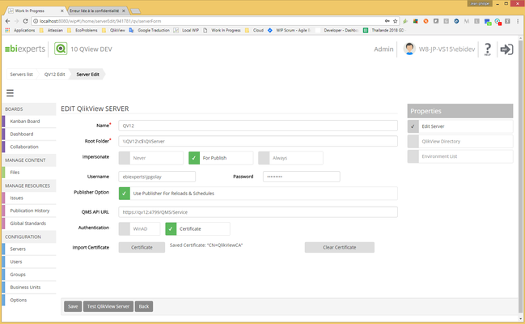
- Fill the QMS API URL as https://qv12:4799/QMS/Service
      - if the QMS url starts with "http" check the WinAD authentication
      - if the QMS url starts with "https", check the Certificate authentication
- Press the Certificate button, select the QMS .pfx file and press save
- Press the "Test QlikView Server" button
Remark : Add the WIP Proxy User in the “QlikView Management API” Group on the Qlik View Publiosher server. If the group does not exists create it

How to export the QMS certificate

Windows / run mmc.exe, Add / Remove Snap-in
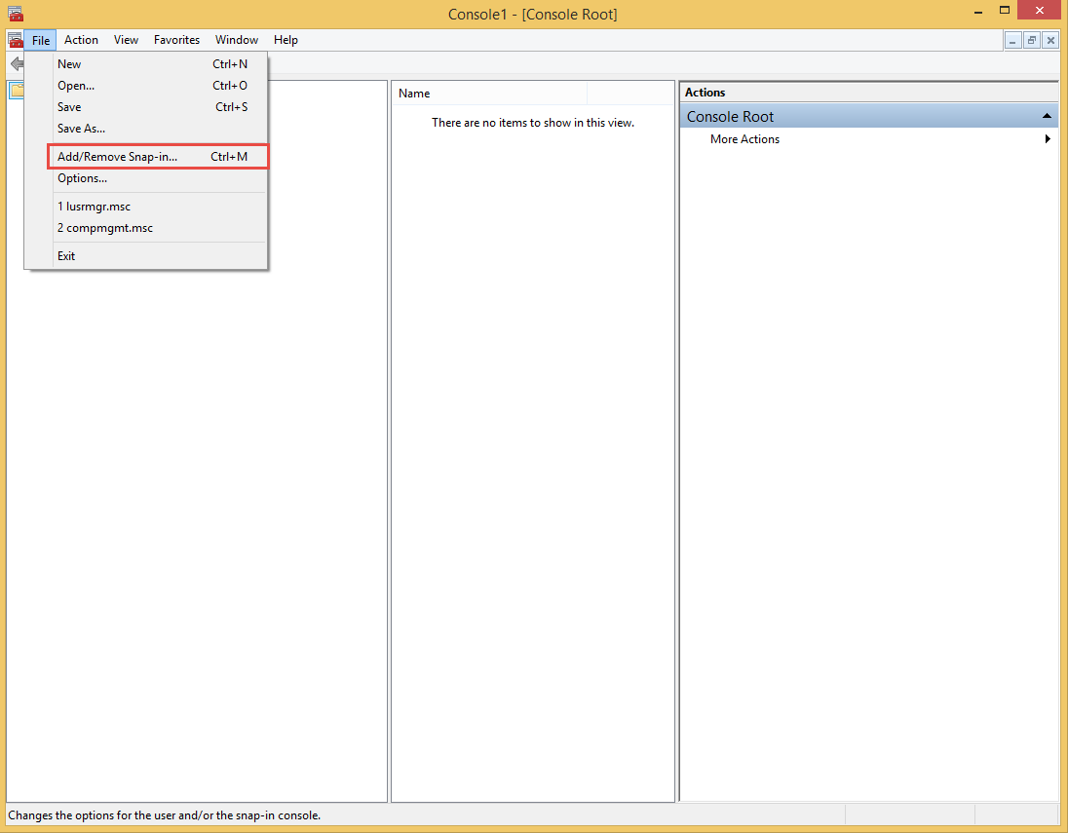
Add certificates / Computer account
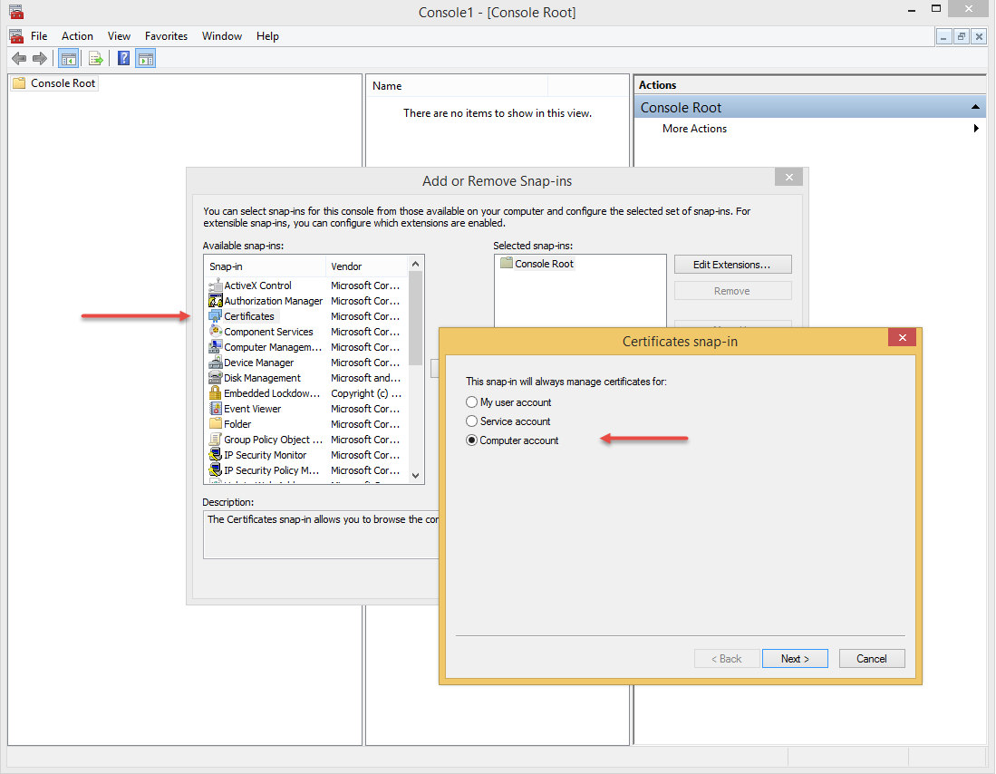

Find the QlikView certificate, issued by is generally "QlikViewCA" and export it
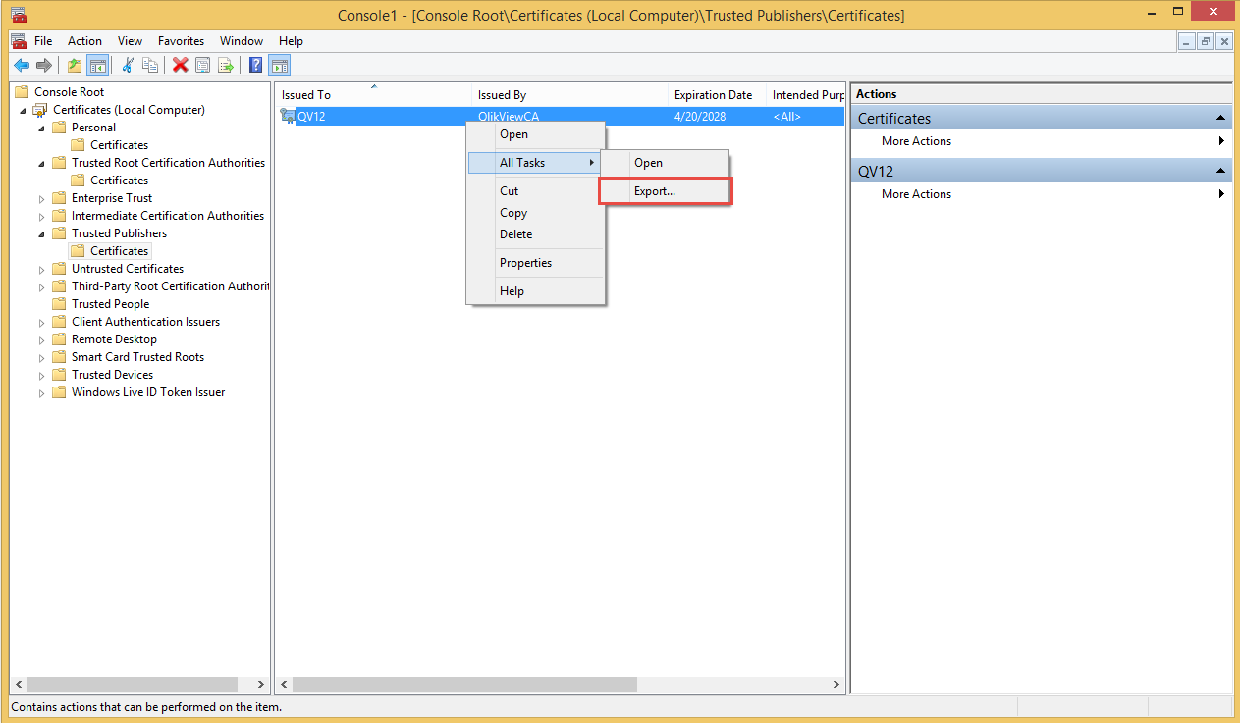
Export the private Key
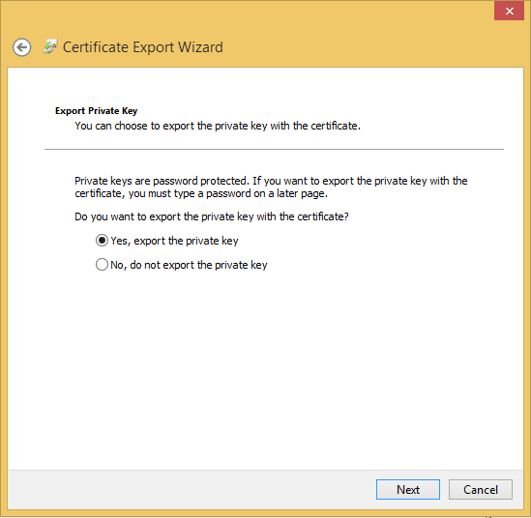
Use Personal Information Exchange – PKCS #12 (.PFX) Format
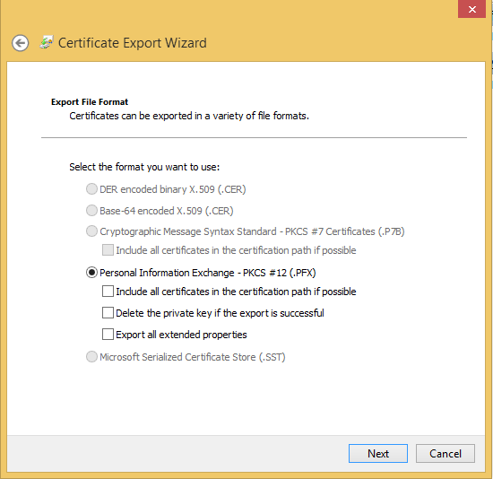

IMPORTANT: Password must be set to "ebiexperts"
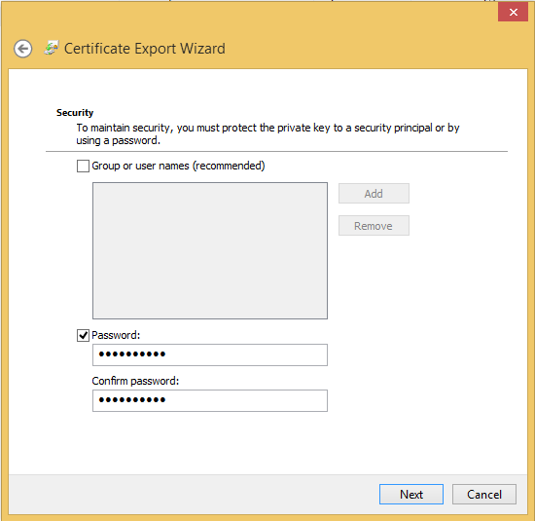
Export the certificate
