QVAUctor ltd

Connect WIP to NPrinting Server
Installation Guidelines

CONFIGURATION MANAGEMENT
Doc ID: | WIP Connect to NPrinting Server | Issue Date: | 04 November 2019
Author: | Golay Jean-Philippe | Status | Production

Table of Contents
1 Overview 2
1.1 Prerequisites 2
2 Installing WIP for NPRINTING 2
2.1.1 NPrinting user’s Roles 2
2.2 Create New NPrinting Server 3
2.3 Import NPrinting Certificate 4
2.3.1 Generate NPrinting certificate 4
2.3.2 Import NPrinting Certificate in WIP 7
2.3.3 Test NPrinting connection 9

Overview

Prerequisites

Please consult WIP Install Guide.pdf for prerequisites

Installing WIP for NPRINTING
Related documentation: see this training video
WIP Training 04 Connect NPrinting Server

NPrinting user’s Roles
In Order to manage NPrinting reports WIP Users must be defined as
Browse / Checkout
- The NPrinting Server browsing and checkout is done using the <WIP Log On> User he must have be an administrator on NPrinting Server in order to export the reports
Publish
- The NPrinting Server publish is done using <WIP Proxy User>. If no <WIP Proxy User> is defined then WIP will use <WIP Log On>. <WIP Proxy User> or <WIP Log On> User he must have be an administrator on NPrinting Server in order to export the reports
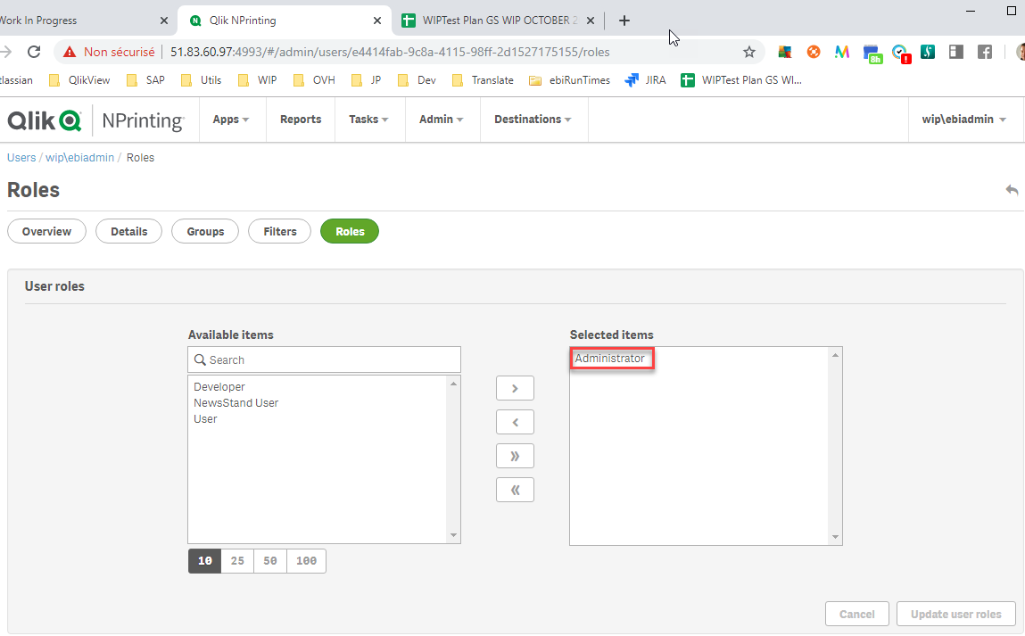

Create New NPrinting Server

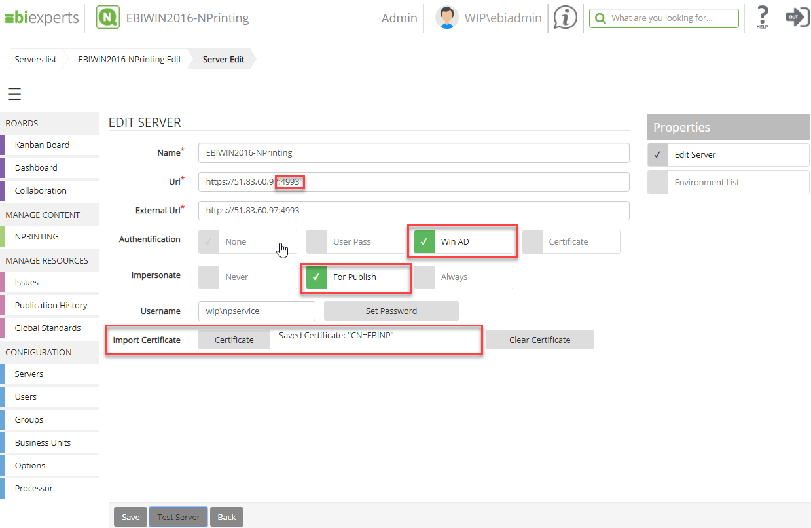
Name: Server name in WIP
Url: The internal NPrinting URL used between WIP and NPrinting
External Url: The external NPrinting URL available for users to connect to NPrinting
Authentication: Always “Win AD”
Impersonate Set “For Publish”
Username Proxy user for publishes
Import Certificate See below Import Certificate

Import NPrinting Certificate
The certificate is just used to encrypt communications between WIP and the NPrinting Server. The authentication will still be done using Active Directory

Generate NPrinting certificate
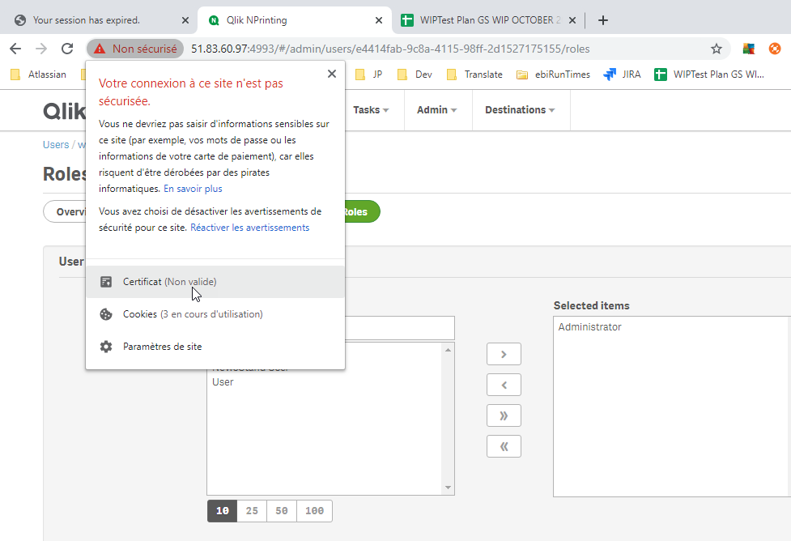
Open NPrinting Url https://<nprintingurl>:4993/
On Chrome Right click on the certificate

In Details tab Press Copy to file
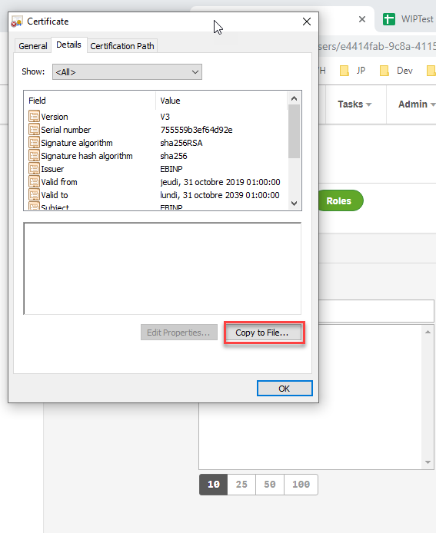

Press Next
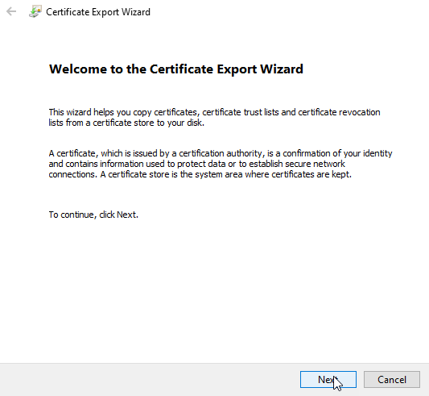

Select DER encoded binary X.509 (.CER)
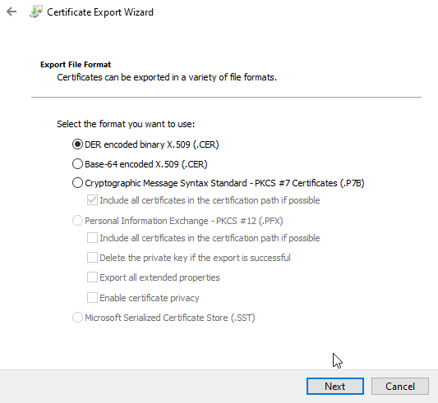

Choose filename and press Next to export

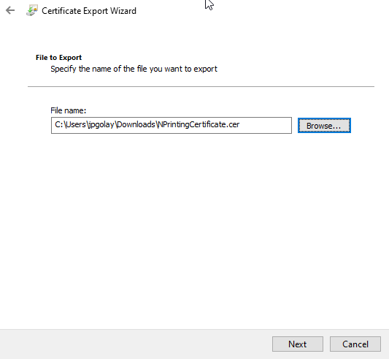

Import NPrinting Certificate in WIP
In WIP NPrinting server press the “Certificate” button, select the just exported NPrinting certificate and press Open.
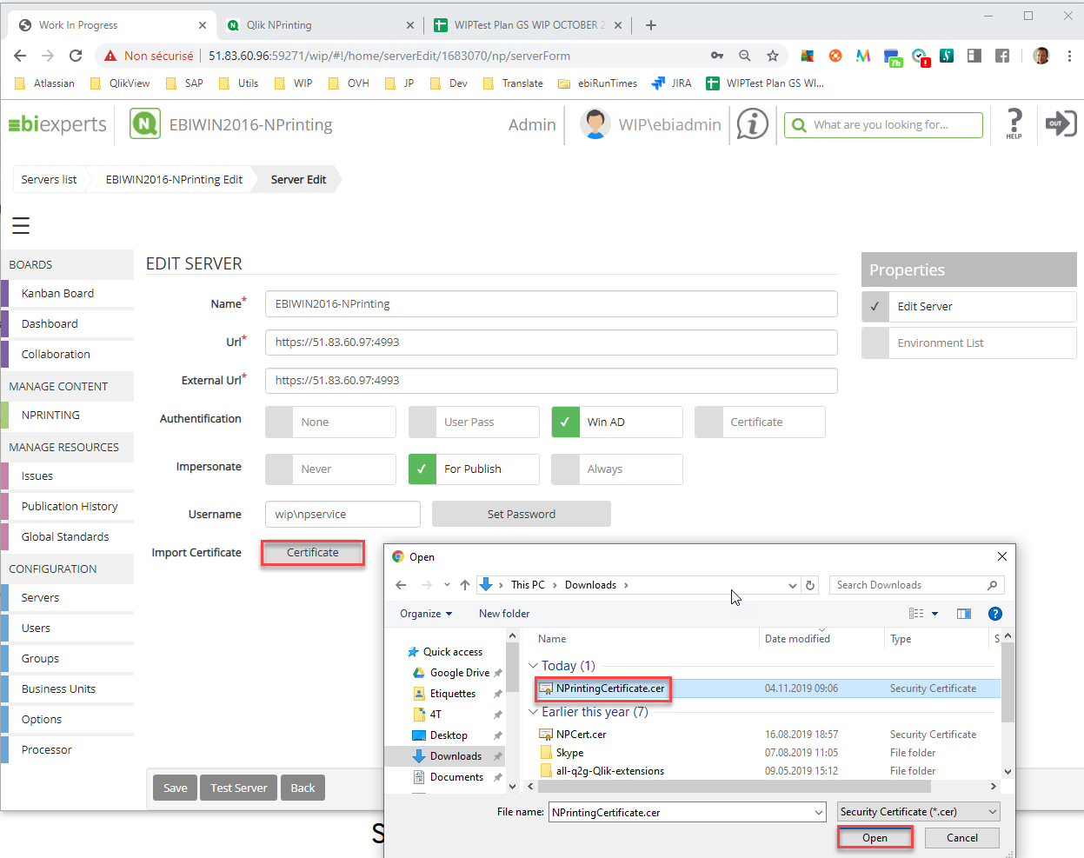

Press Save and Import button
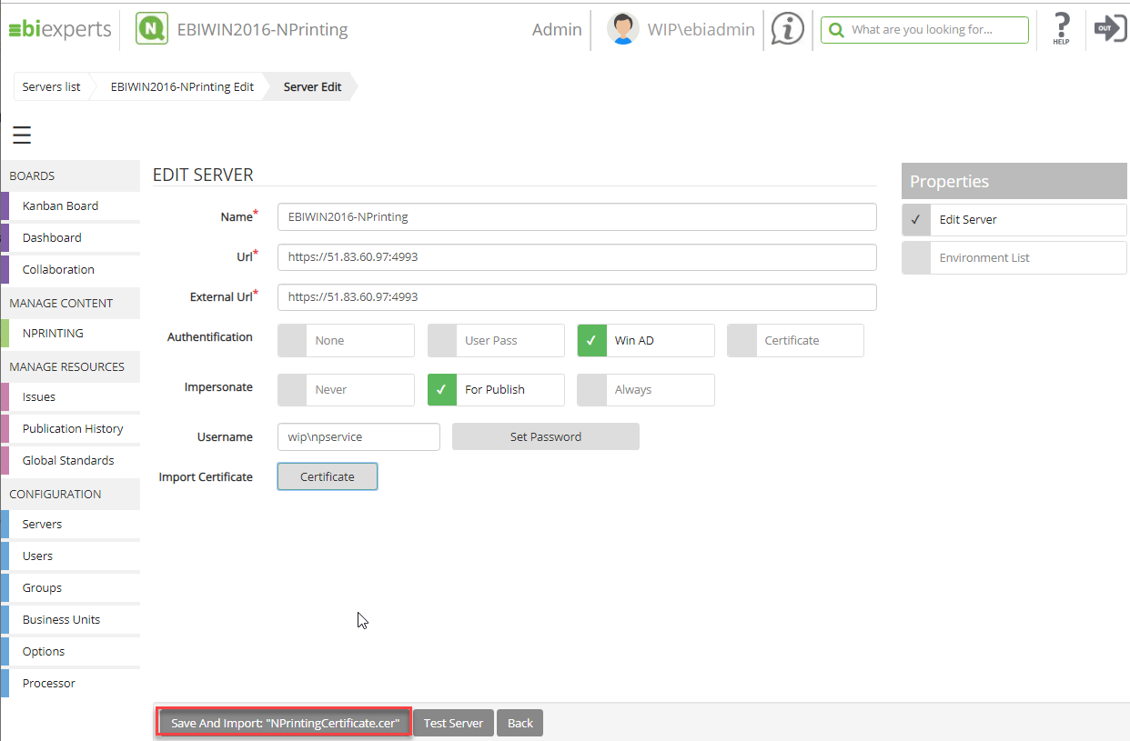
WIP should display “Saved Certificate CN=…”
Press Test Server
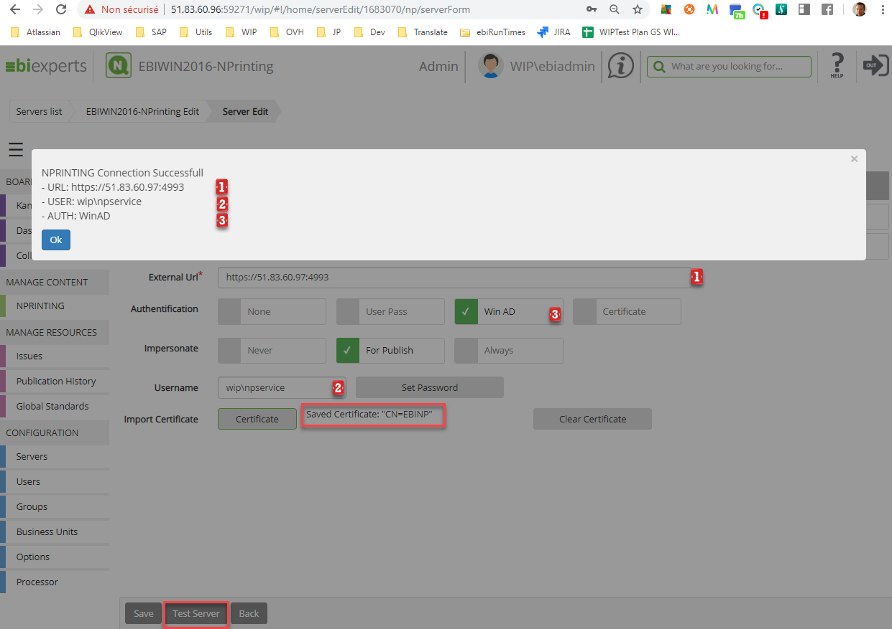

Test NPrinting connection
Create a user in WIP that is defined as an Administrator in NPrinting (see NPrinting user’s Roles)
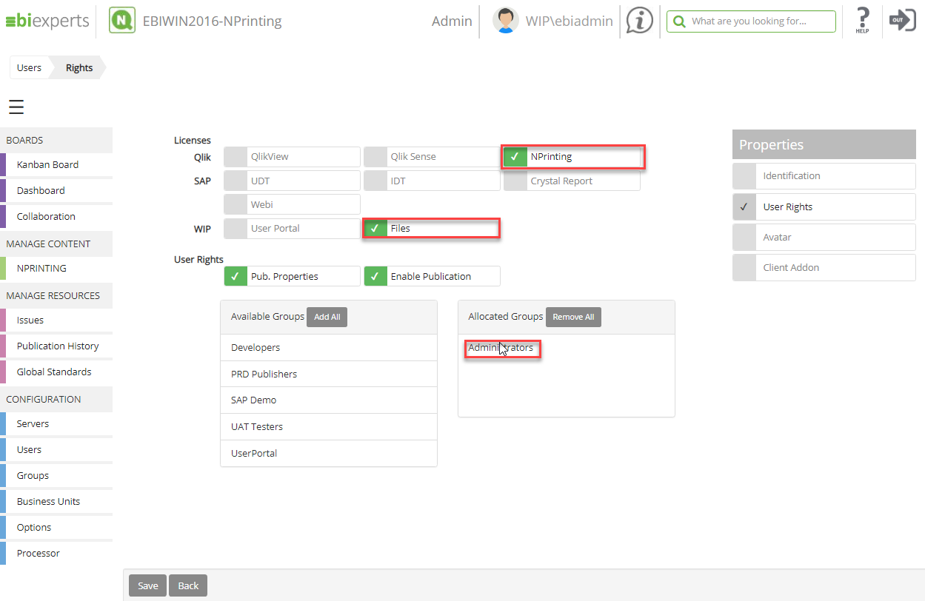

Test the NPrinting server, log on WIP with a user with a NPrinting license assigned
open NPRINTING in MANAGE CONTENT, create a root folder and press the N icon, browse a report and press “Check-in(1)”

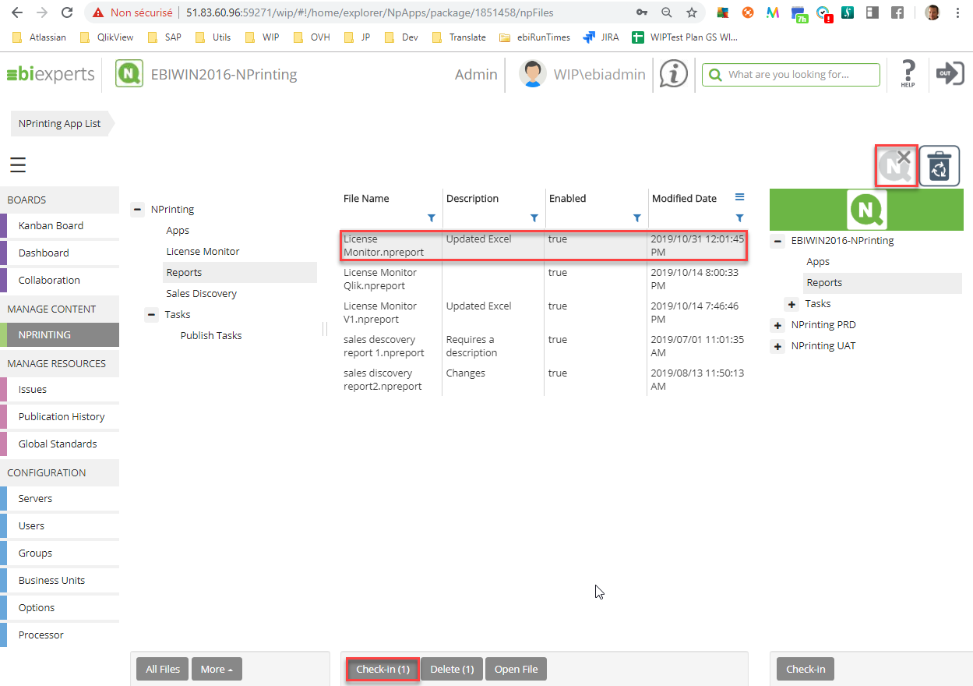

Et voilà WIP is now connected to NPrinting, for any issue please contact ebiexperts Support at support.ebiexperts.com

